ONLY THE FATTEST MAY SURVIVE: HOW GENOTYPE AFFECTS DIAPAUSE STRATEGY OF EUROPEAN CORN BORER, *Ostrinia nubilalis* (LEPIDOPTERA: CRAMBIDAE)

By

JAMES T. BROWN

A THESIS PRESENTED TO THE GRADUATE SCHOOL

OF THE UNIVERSITY OF FLORIDA IN PARTIAL FULFILLMENT

OF THE REQUIREMENTS FOR THE DEGREE OF MASTER OF SCIENCE

UNIVERSITY OF FLORIDA

2019

 2019 James T. Brown

To my family

ACKNOWLEDGMENTS

I thank my major adviser Dr. Daniel Hahn for supporting my research and professional development, and I thank my committee members Dr. John Beck and Dr. Robert Meagher for their pragmatism and unique perspectives. I also thank Dr. Qinwen Xia-Chen, Dr. Chao

Chen, Nausheena Baig, and Dr. Caitlin Rering for their assistance with experimental design,

Dr. Andrew Nguyen for his assistance with data analysis, and Dr. Charles Stuhl, Dr. Leigh Boardman, Clancy Short, and Dylan Tussey for stimulating my intellect and inspiring ideas. I also thank the Entomology and Nematology Department of the University of Florida and the

United States Department of Agriculture, Agricultural Research Services, Center for Medical, Agricultural, and Veterinary Entomology (USDA-ARS CMAVE) for supporting me financially during my degree program. Finally, I thank every student in the Entomology and Nematology

Student Organization for their friendship and support.

TABLE OF CONTENTS

ACKNOWLEDGMENTS . . . . . . . . . . . . . . . . . . . . . . . . . . . . . . . . . . . 4

LIST OF TABLES . . . . . . . . . . . . . . . . . . . . . . . . . . . . . . . . . . . . . . 6

LIST OF FIGURES . . . . . . . . . . . . . . . . . . . . . . . . . . . . . . . . . . . . . 7

ABSTRACT . . . . . . . . . . . . . . . . . . . . . . . . . . . . . . . . . . . . . . . . . 8

CHAPTER

1. INTRODUCTION . . . . . . . . . . . . . . . . . . . . . . . . . . . . . . . . . . . 9
2. THE EUROPEAN CORN BORER, *Ostrinia nubilalis* (LEPIDOPTERA: CRAMBIDAE) 13
   1. Phylogeny of *Ostrinia nubilalis* . . . . . . . . . . . . . . . . . . . . . . . . . 14
   2. Life History of *Ostrinia nubilalis* . . . . . . . . . . . . . . . . . . . . . . . . . 17
3. EUROPEAN CORN BORER: THE RELATIONSHIP BETWEEN STORED RESOURCES AND DIAPAUSE TIMING . . . . . . . . . . . . . . . . . . . . . . . . . . . . . . . 21
   1. Background . . . . . . . . . . . . . . . . . . . . . . . . . . . . . . . . . . . 21
   2. Methods . . . . . . . . . . . . . . . . . . . . . . . . . . . . . . . . . . . . . 22
      1. General Rearing . . . . . . . . . . . . . . . . . . . . . . . . . . . . . . 22
      2. Experiment 1: Estimating the Onset Diapause and Classifying Diapause-Programmed Larvae Using Metabolic Activity . . . . . . . . . . . . . . 23
      3. Experiment 2: The Onset of Wandering and Measuring Stored Lipids 25
      4. Statistical Analyses . . . . . . . . . . . . . . . . . . . . . . . . . . . . 27
      5. Results . . . . . . . . . . . . . . . . . . . . . . . . . . . . . . . . . . . . . . 28
      6. Experiment 1: Metabolic Activity . . . . . . . . . . . . . . . . . . . . 28
      7. Experiment 2: Stored Lipids . . . . . . . . . . . . . . . . . . . . . . . 30
   3. Discussion and Conclusions . . . . . . . . . . . . . . . . . . . . . . . . . . . 31

LIST OF REFERENCES . . . . . . . . . . . . . . . . . . . . . . . . . . . . . . . . . . . 51

BIOGRAPHICAL SKETCH . . . . . . . . . . . . . . . . . . . . . . . . . . . . . . . . . 56

LIST OF TABLES

# Table

2-1 Subgroups of *Ostrinia* uncus group III using mid-tibiae length . . . . . . . . . . . . 19

3-1 Comparing CO2 production between individuals reared in diapause programming

and non-diapause conditions. . . . . . . . . . . . . . . . . . . . . . . . . . . . . . 46

3-2 Model selection by factor elimination for lean mass accumulation prior to the onset

of diapause . . . . . . . . . . . . . . . . . . . . . . . . . . . . . . . . . . . . . . . 47

3-3 Linear mixed effect model comparison of lean mass accumulation between diapause

genotypes before the onset of diapause . . . . . . . . . . . . . . . . . . . . . . . . 47

3-4 Model selection by factor elimination for lipid mass accumulation prior to the onset

of diapause . . . . . . . . . . . . . . . . . . . . . . . . . . . . . . . . . . . . . . . 48

3-5 Linear mixed effects model comparison of lipid mass accumulation between genotypes

before the onset of diapause . . . . . . . . . . . . . . . . . . . . . . . . . . . . . . 48

3-6 Model selection by factor elimination for lean mass depletion during diapause . . . . 49

3-7 Comparing lean mass depletion between diapause genotypes during diapause . . . . 49

3-8 Model selection by factor elimination for lipid mass depletion during diapause . . . . 50

3-9 Comparing lipid mass depletion between diapause genotypes during diapause . . . . 50

LIST OF FIGURES

# Figure

|  |  |
| --- | --- |
| 1-1 Predictive the relationship between nutrition stores and diapause genotype. . . . . . | 12 |
| 2-1 Chemical structure of sex pheromone components . . . . . . . . . . . . . . . . . . | 20 |
| 3-1 Observations of larvae in diapause programming conditions . . . . . . . . . . . . . | 37 |
| 3-2 Wandering assay tray . . . . . . . . . . . . . . . . . . . . . . . . . . . . . . . . . | 38 |
| 3-3 Distribution of larvae entering the wandering stage . . . . . . . . . . . . . . . . . .  3-4 Accumulation of wet mass among larvae in diapause programming and non-diapause | 39 |
| conditions. . . . . . . . . . . . . . . . . . . . . . . . . . . . . . . . . . . . . . . .  3-5 Comparing CO2 production between larvae with different diapause genotypes when | 40 |
| reared under the same photoperiod . . . . . . . . . . . . . . . . . . . . . . . . . .  3-6 Comparing CO2 production between larvae with the same diapause genotype when | 41 |
| reared in different photoperiods . . . . . . . . . . . . . . . . . . . . . . . . . . . .  3-7 Comparing wet mass accumulation and CO2 production between shallow-diapause | 42 |
| and deep-diapause larvae with the short-diapause genotype . . . . . . . . . . . . .  3-8 The effect of diapause programming on lean mass and lipid mass accumulation prior | 43 |
| to the onset of diapause . . . . . . . . . . . . . . . . . . . . . . . . . . . . . . . .  3-9 The effect of diapause programming on lean mass and lipid mass depletion during | 44 |
| diapause . . . . . . . . . . . . . . . . . . . . . . . . . . . . . . . . . . . . . . . . | 45 |

Abstract of Thesis Presented to the Graduate School of the University of Florida in Partial Fulfillment of the Requirements for the Degree of Master of Science

SEASONAL CUES AND DIAPAUSE PREPARATION IN THE EUROPEAN CORN BORER, *Ostrinia nubilalis* (LEPIDOPTERA: CRAMBIDAE)

By

James T. Brown

May 2019

Chair: Daniel A. Hahn

Major: Entomology and Nematology

Diapause is a genetically determined life history strategy commonly used by many insects in temperate regions to avoid the consequences associated with low winter temperatures. Because food is scarce during winter, insects conserve energy by decreasing metabolic activity and suspending development. To meet the energy demands of their suppressed metabolism during diapause, insects often accumulate greater energy reserves before the onset of winter. Moreover, after diapause ends, some insects rely on that same pool of stored energy to complete metamorphosis, find mates, and reproduce. Climate change is predicted to impact diapausing insects as warmer and more variable winter temperatures increase metabolic activity, possibly reducing energy stores. How temperate-insects manage nutrition in preparation for diapause and during diapause in response to climate change could be crucial in determining which insects will survive warmer temperatures. Using two strains of *Ostrinia nubilalis* (Hubüner) reared in conditions that induce diapause and measuring lipid storage, my goal was to determine the degree to which different diapause genotypes (long-diapause and short-diapause) affect nutrition accumulation in preparation for diapause and nutrition depletion during diapause. European corn borers of both genotypes increased lipid stores when programmed for diapause, and lipid stores among diapause-programmed larvae were higher among larvae with the long-diapause genotype compared to the strain with the short-diapause genotype. However, I did not detect a difference in lipid depletion during diapause between the long-diapause and short-diapause genotypes. Reducing lipid stores before the onset of diapause could limit energy available to fuel metabolic activity during diapause and could be one way to manage *O. nubilalis* pest populations. Before using the diapause genotype as a tool to predict pest population responses to climate change, more research must be done to better understand the relationship between nutrient management, diapause length, and overwintering survival.

CHAPTER 1

INTRODUCTION

What are the factors that affect dormancy and life history timing? How do animals synchronize their life history with seasonal variation? To what degree does environmental variation alter phenotypes? In temperate regions, seasons cycle predictably between favorable spring and summer and unfavorable fall and winter. Winters in temperate regions are cold, dry, and nutrition is unavailable. Some insects in these regions have evolved seasonal dormancy (diapause) as a strategy to protect themselves from the unfavorable winter environment. Diapause is an alternative life history trajectory that is induced before the start of unfavorable conditions that leads to major physiological changes. There is substantial genetic variation in diapause-associated life history traits both within and among species. Variation in diapause traits may serve to synchronize insect life histories with predictable seasonal change. Genetic variation in diapause is also critical for diapause to evolve by natural selection. Climate change can lead to disruptions in diapause-mediated life history synchrony between insects and their environments as seasons become less predictable. Insects that are successful or are positively impacted by the warmer temperatures and longer growing seasons associated with climate change could be termed "winners" and insects that are negatively impacted by warming temperatures and shifting seasons could be termed "losers". Genetic variation in diapause traits could prove to be beneficial as climate changes and seasonality becomes less predictable.

In temperate regions, warm temperatures persist in the spring and summer. During the warm season, insects use available food and water to grow, develop, and reproduce. As temperatures decline in the fall and winter, resources become scarce. For insects in temperate regions, low temperatures can greatly reduce metabolic activity making continued activity challenging or even impossible. To overcome the challenges faced during winter, many temperate dwelling insects use diapause. Diapause is a genetically regulated and environmentally influenced alternative developmental trajectory initiated before the onset of winter and during a species-specific life stage (Koštál, 2006). By monitoring environmentally consistent cues that cycle with seasonality, insects can reliably predict, prepare for, and protect themselves from unfavorable changes in seasonal temperature and resource availability by initiating diapause. To predict seasonal change, temperate insects generally use photoperiod alone or in concert with other environmental cues, like temperature or host-plant quality, to induce diapause before arrival of prolonged seasonal stress.

The onset of diapause is generally marked by the suspension of development, a reduction in metabolic activity, and during diapause many insects do not feed (Hahn and Denlinger, 2007; Koštál, 2006; Sinclair, 2015; Tauber and Tauber, 1981). However, diapausing insects must continue to meet the energetic demands of their metabolism during diapause. In addition to the added energy cost incurred by surviving winter in diapause, insects exiting diapause must also have enough energetic and anabolic resources left to resume development.

In preparation for diapause many insects store additional lipids to use as fuel during diapause, however nutrition is also stored in the form of carbohydrates and proteins (Arrese and Soulages, 2010; Hahn and Denlinger, 2007). For insects that use diapause, the decision to switch developmental trajectories, the timing of diapause induction, accumulating enough nutrition during diapause preparation, and the rate stored energy is depleted during diapause are each crucial to its survival. If the onset of diapause occurs before the favorable season ends it will limit an insects ability to take advantage of available resources. Early entry into diapause could also lead to the premature depletion of stored nutrients as metabolic activity during diapause relies on stored energy. If the onset of diapause is late and occurs after the unfavorable season begins an insect could be exposed to conditions that could cause mortality.

The goal of this study is to characterize the relationship between nutrition storage and diapause genotype. Using two strains of *Ostrinia nubilalis* (European corn borer) with different diapause genotypes, I tested the degree to which diapause genotype affects nutrition storage. Specifically, I tested the degree to which diapause genotype could be associated with lipid storage during diapause preparation in European corn borer. I expected insects with a longer diapause genotype to store more lipids than insects with a shorter diapause genotype in preparation for diapause (1-1A,B). When I programmed larvae for diapause and compared each diapause genotype I found that larvae with a longer diapause genotype showed an increase in lipid storage in relation to individuals with the short-diapause genotype. I also sampled larvae during diapause, expecting no difference in lipid depletion between the longer diapausing genotype and the shorter diapausing genotype. I found similar lipid depletion rates between each diapause genotype but my data are too sparse thoroughly assess this pattern. Whether the accumulation of other nutrient macromolecules, specifically proteins and carbohydrates, follows the same pattern as lipid stores remains to be tested.

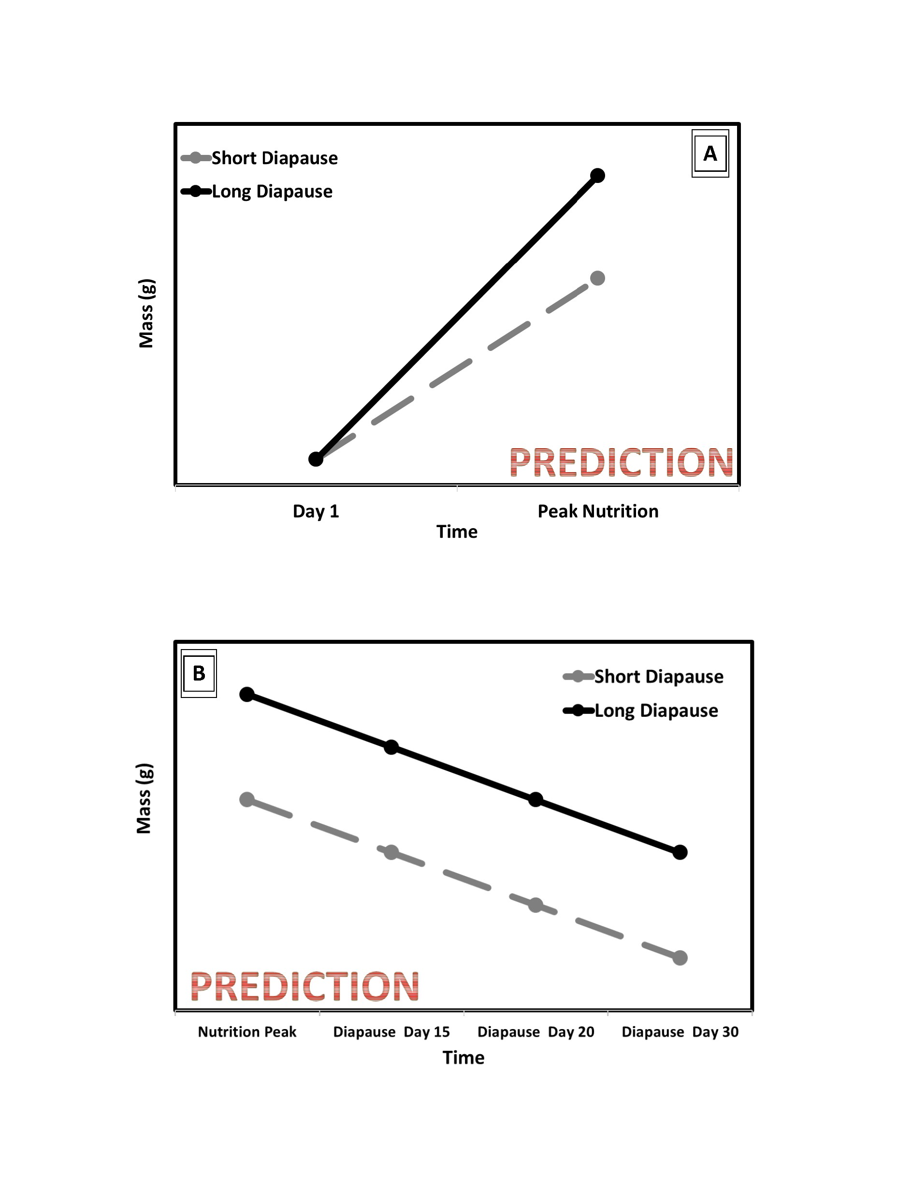

Figure 1-1. Hypothesis based prediction of the relationship between diapause genotype and lipid storage in preparation for diapause (A) and depletion during diapause (B).

CHAPTER 2

THE EUROPEAN CORN BORER, *Ostrinia nubilalis* (LEPIDOPTERA: CRAMBIDAE)

*Ostrinia nubilalis*, the European corn borer (ECB), is a phytophagous moth in the family Crambidae. *O. nubilalis* and it occurs in most states east of the Rocky Mountains from Canada to the Gulf of Mexico (Beck and Apple, 1961; Bohnenblust and Tooker, 2010; Capinera and Department), 2000). The host range of the European corn borer is particularly wide and includes grasses, vegetables, and other herbaceous plants with a stem large enough for the larvae to enter (Capinera and Department), 2000). In the mid-Atlantic and Midwestern regions of the United States, the European corn borer remains the primary insect pest of corn. The cost of controlling this corn pest has been approximated at $1-$2 billion dollars, annually (Hyde et al., 1999). These pests use programmed seasonal dormancy (diapause) to synchronize their life histories with favorable seasons and take advantage of available resources, like corn. At least two diapause genotypes (strains) of European corn borer populations occur in the United States. One strain has a diapause genotype that produces a relatively short diapause length and the other has a diapause genotype that produces a relatively long diapause length. Those insects with the shorter diapause length exit diapause earlier in the spring and the longer diapausing insects exit diapause later in the spring (Levy et al., 2015; Showers et al., 1975).

At the poleward edge of the *O. nubilalis* population range warm spring and summer seasons are short and these pests can complete only one generation per year. As latitude decreases the warm growing season gradually becomes longer. In studying a seasonal cline from north to south, Levy et al. (2015) found polymorphisms in the genes responsible for diapause length are in part responsible for differences in voltinism observed across latitudes. Each polymorphism plays an important role when diapause is terminated and influences the number of generations each strain can produce annually. At the poleward boundary of the population range, populations with a short diapause length exit diapause earlier in the spring to take full advantage of the short warm season. After diapause ends, larvae develop into functional adults capable of generating one generation of larvae. At the end of the short growing season the short diapause length genotype has enough time to enter diapause before winter arrives. Further south, the growing season is longer providing the short diapause length enough time to produce two generations of larvae. The first generation of larvae mature into adults and produce an additional generation of larvae while the second generation of larvae have enough time to enter diapause before winter begins. The longer growing season is also favorable for the ECB that emerge later in the spring. These larvae with a longer diapause length exit diapause later in spring and produce one generation of larvae able to enter diapause before the start of winter. The sequential emergence of these pests from diapause increases the number of generations produces at each latitude each year contributing to this pest’s continued success.

The effects of anthropogenic climate change will lead to longer growing seasons and as poleward regions will become warmer more geography will be thermally favorable to ECB, thus both the geographic range and voltinism at each point in the range may be increased. Research into the relationship between diapause phenology, nutrition management in preparation for diapause, and how these pests could respond to changing climate could provide possible targets for future pest management.

2.1 Phylogeny of *Ostrinia nubilalis*

The appearance of lepidopterans (butterflies and moths) 190 million years ago marks an important moment in insect evolutionary history (de Gruyter, 1999). This order is primarily plant feeding and the enormous lineage diversification following the emergence of this order corresponds to the colonization of angiosperm hosts by larvae (Regier et al., 2012; Wahlberg et al., 2013). Since its divergence, Pyraloidea represent one of the most diverse superfamilies of Lepidoptera. These lepidopterans feed on almost every major plant group and occupy an enormous diversity of ecological habitat. Pyraloidea moths are major pests of crops, invasive plants, forests, ornamentals, and stored foods (Dugdale, 1995; Regier et al., 2012). The divergence of the superfamily Pyraloidea occurred approximately 100 million years ago during the Cretaceous period (Wahlberg et al., 2013). Broadly, Pyraloidea moths share morphological synapomorphies including scales at the base of their proboscis, similar wing structures, and paired tympanal organs (Regier et al., 2012). Nested within Pyraloidea are families Crambidae with approximately 10,000 described species and Pyralidae with approximately 5,000 described species (Solis, 2007). Differences in tympanal structures, wing venation, and male genetalia differentiate these two families (Solis, 2007). Species in the family Crambidae occupy most every ecological niche, this family is polyphagous, and many species are important agricultural pests.

The genus *Ostrinia* exists within the family Crambidae. This genus includes 20 species recorded worldwide with each species belonging to either group I, II, or III. Groups are determined based on the number of "uncus" lobes associated with the male genitalia (Allison and Cardé, 2016; Frolov et al., 2007). Group I includes a single member, the American species *Ostrinia penitalis* (Grote) characterized by having an "unarmed" sacculus and a trifid juxta in the male genitalia (Allison and Cardé, 2016). Species in group II have a simple or bifid uncus. There are ten species in the trilobed uncus group (group III), all of which are morphologically similar with one clear distinction; male mid-tibia length (2-1). The mid-tibiae and associated structures participate in pheromone emission and are used to subdivide the members of group III with "small", "medium", and "massive" mid-tibiae lengths (Allison and Cardé, 2016; Frolov et al., 2007). The distinction of group III species extends to ecological preferences, including two important agricultural pests, *Ostrinia furnacalis* (Guenée), the Asian corn borer and *Ostrinia nubilalis*, the European corn borer (Allison and Cardé, 2016; Frolov et al., 2007; Kim et al., 1999). The Asian corn borer and the European corn borer population ranges do not overlap with one another, however each species does live in sympatry its ancestral species, the adzuki bean borer, *Ostrinia scapulalis* (Walker) (Frolov et al., 2007). Across group III specific isomers of tetradecyl-acetate (14:OAc) are produced at species-specific concentrations and drive male attraction to females (Frolov et al., 2007). Differences in pheromone component concentrations is thought to be a strong driver maintaining isolation between these different

*Ostrinia* species and between different genotypes of *O. nubilalis*.

Sex pheromone biosynthesis in European corn borer females involves the *β*-oxidation of palmitic acid into (Z)-11-tetradecenoyl and (E)-11-tetradecenoyl precursors that can be reduced into their corresponding fatty alcohols then acylated into a pheromone molecule (Lassance et al., 2010). The specific ratio of precursor molecules converted into pheromone differs between two naturally segregating z-chromosome genotypes (Lassance et al., 2010). The gene responsible for pheromone synthesis has two different alleles. Higher concentrations of (Z)-11-tetradecenyl acetate (2-1A) in the Z strain sex pheromone blend is due to affinity of (Z)-11-tetradecenoyl precursors to the fatty acid reductase enzyme produced from the pgFAR-Z allele (Lassance et al., 2010). Alternatively, the high concentration of (E)-11-tetradecenyl acetate (2-1B) characteristic of the E strain is due to the increased affinity of (E)- 11-tetradecenoyl precursors to the fatty acid reductase produced from the pgFAR-E allele (Lassance et al., 2010). In addition to the sex pheromone barrier between the two strains of European corn borer, reproductive isolation is also supported by temporal isolation of each species through the timing of diapause.

The onset of diapause in European corn borer is environmentally programmed by photoperiod and temperature but the length of diapause varies between strains. The Pdd region of the Z-chromosome is a major factor associated with diapause length and is partially responsible for determining voltinism during the growing season (Dopman et al., 2005). The univoltine and bivoltine genotypes express longer and shorter diapause phenology respectively, as well as differences in their pheromone blend. Univoltine Z strain larvae (UZ) enter diapause earlier in the fall and exit diapause later in the spring compared to the bivoltine E strain genotype (BE). Longer diapausing individuals are sexually mature later during the growing season than individuals with a the shorter diapause. The different strains of European corn borer are suitable model to investigate the causes and consequences of speciation, especially as environmental conditions become less stable due to climate change.

2.2 Life History of *Ostrinia nubilalis*

*Ostrinia nubilalis* (European corn borer, ECB) have evolved in the temperate regions where it encounters favorable and unfavorable seasonal changes. During spring and summer, long day lengths (photoperiod) and warm temperatures favor continuous growth and development and the life cycle of ECB can be completed in fifty days. Beginning in the spring and under field conditions, diapausing larvae exit diapause, develop into pupae, and approximately 12 days later those pupae eclose as adults and eventually begin mating

(Capinera, 2000). Oviposition in sexually mature adults lasts approximately 14 days with females laying between 20 and 50 eggs each day and 400 to 600 eggs across its lifetime (Capinera, 2000). The flattened, scale like eggs are usually deposited on the underside of leaves and hatch four to nine days after being laid. In the field, larvae proceed through six larval instars. Similar to many lepidopterans. Once larval growth is completed *O. nubilalis* larvae enter the wandering stage (Capinera, 2000). Wandering is characterized by the termination of feeding and the clearing of the larval gut in preparation for the next developmental step (Gelman and Hayes, 1982). As summer ends and fall begins, shorter photoperiods and lower temperatures become unfavorable to the continued growth and development of ECB. In the fall after the wandering stage ends competent larvae recognize the shorter photoperiod, suspend their development and enter diapause.

Diapause is a state of increased stress tolerance, marked by developmental arrest and suppressed metabolic activity (Hahn and Denlinger, 2007; Tauber and Tauber, 1981). Photoperiods are latitude specific and have reliably cycled with seasonal changes. Because of its specificity, many animals in temperate regions rely on photoperiod cues to synchronize their life histories with their local environment to initiate diapause. Ahead of winter and during the final larval instar ECB become sensitive to photoperiod. When photoperiod reaches a critical threshold it initiates the diapause genotype and programs ECB larvae for diapause. Within *O. nubilalis* at least two different diapause genotypes exist with genetically different diapause lengths (Levy et al., 2015; Roelofs et al., 1985; Showers et al., 1975). The initiation of diapause leads to major physiological changes and alters the life history trajectory of European corn borer larvae. Diapausing larvae depend on predictable cues to initiate and terminate diapause. Climate change and warmer temperatures could affect the synchrony between European corn borer life history and its environment, and understanding these effects may be crucial to how we manage this pest.

Table 2-1. Adapted from Frolov et al. 2007. Mid-tibiae length of male *Ostrinia* species as described by Mutuura & Munroe (1970) (Mutuura and Munroe, 1970)

|  |  |
| --- | --- |
| Uncus size | Species |
| Small |  |
|  | *O. nubilalis*  *O. orientalis*  *O. furnacalis*  *O. dorsivittata* |
| Medium |  |
|  | *O. narynensis*  *O. kurentzovi* |
| Large |  |
|  | *O. scapulalis*  *O. zaguliaevi O. zealis*  *O. putzufangensis* |

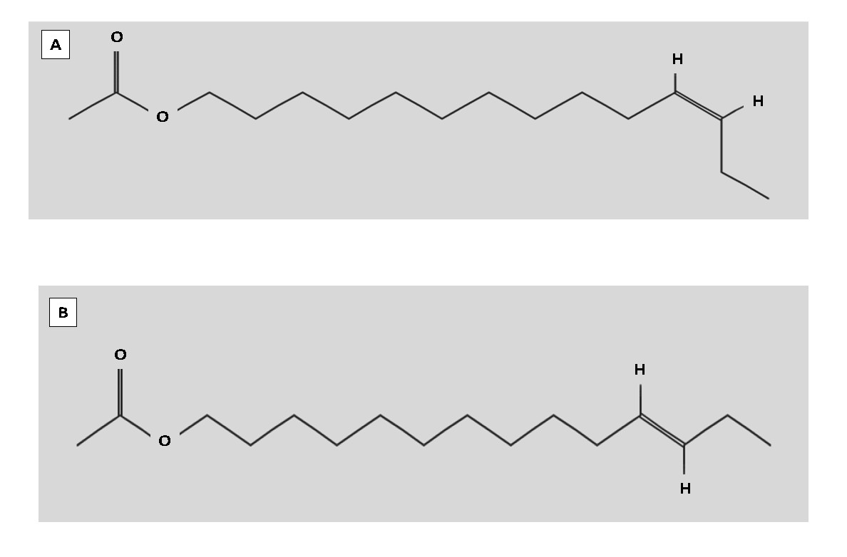

Figure 2-1. (A) Chemical structure of (Z)-11-tetradecenyl acetate, the major sex pheromone molecule produced primarily by Z strain females. National Center for Biotechnology Information. Source: PubChem Compound Database; CID=5367692. Reprinted with permission from Pubchem Open Chemistry Database

https://pubchem.ncbi.nlm.nih.gov/compound/5367692 (November 6, 2018). (B) Chemical structure of (E)-11-tetradecenyl acetate, the major sex pheromone molecule produced by E strain females. National Center for Biotechnology Information. Source: PubChem Compound Database; CID=5367650. Reprinted with permission from Pubchem Open Chemistry Database https://pubchem.ncbi.nlm.nih.gov/compound/5367650 (November 6, 2018).

CHAPTER 3

EUROPEAN CORN BORER: THE RELATIONSHIP BETWEEN STORED RESOURCES AND

DIAPAUSE TIMING

3.1 Background

According to the National Oceanic and Atmospheric Administration, 2016 was the warmest year on record and temperature increases are expected to continue through the year 2100 (NOAA, 2017; DeLucia, 2008; IPCC, 2013). As seasonal temperatures increase, the duration of warm summers will expand, cool winters will contract, and temperatures during the spring and fall will become less predictable (NOAA 2016; DeLucia et al., 2008). Animals monitor variation in seasonal factors like temperature and photoperiod (daylight hours) because these factors can affect the availability of nutrition, mates, and habitat. Seasonality predictably cycles between conditions that are favorable for insect activity and conditions that are stressful and unfavorable. Many temperate-dwelling insects protect themselves from seasonal stress by entering diapause before their environment becomes unfavorable (Koštál, 2006).

Insects in diapause can survive for months exposed to harsh conditions and typically do so without access to nutrition by lowering their metabolic activity and suspending their development (Necholset al., 1999; Hahn and Denlinger, 2007). Before the environment becomes unfavorable, insects prepare for diapause by accumulating and storing nutrients in the form of lipids, proteins, and carbohydrates (Hahn and Denlinger, 2007; Hahn and Denlinger, 2011). Increased protein storage has been reported in Colorado potato beetles (*Leptinotarsa decemlineata*) (Kort and Koopmanschap, 1994) and southwestern corn borers (*Diatrea grandiosella*) (Brown and Chippendale 1978), and increased lipid storage has been reported for the pink bollworm (*Pectinophora gossypiella*) (Adkisson et al., 1963) and *Culex pipens* mosquitoes (Mitchell and Briegel, 1989), among others ahead of diapause. The energy insects store during diapause preparation fuel insect metabolism during diapause, and after diapause these stored resources are redirected to accomplish post-diapause functions. However, metabolic activity for many insects is temperature dependent. Thus, insects preparing for diapause in warmer environments may struggle to meet the energy demands of increased metabolism and possibly divert resources away from storage.

Insects entering diapause without adequate nutrition stores may exit diapause before winter ends, leaving them exposed to an unfavorable environment and thereby increasing mortality. A study using the blowfly *Calliphora vicina* (Robineau-Desvoidy) as a model explored the effect of nutrition on the duration of diapause (Saunders, 1997). The authors found that when diet was restricted, larvae entered diapause with less mass and remained in diapause for a shorter period compared to larvae given an unrestricted diet (Saunders, 1997). Insects that exit diapause early could be exposed to stressful low winter temperatures or they may not have enough stored nutrients and other metabolic substrates remaining to meet the anabolic requirements for post-diapause development, metamorphosis, repair, and other post-diapause activities like reproduction (Hahn and Denlinger, 2007; Sinclair, 2015).

Warmer and more variable fall and winter temperatures will increase insect metabolic activity and could deplete nutrition stores because insect metabolism is proportional to the environmental temperatures they experience (Bradshaw and Holzapfel, 2006; Hahn and Denlinger, 2011; Scriber 2014, Sinclair, 2018). For example, Thompson and Davis (1981) reared *Diatrea grandiosella* Dyar moths at stable temperatures during larval feeding and diapause preparation. Then at the onset of larval diapause, some moths were held at warmer and more variable temperatures while others were held in cooler and more stable temperatures. Between the two groups, the moths held in warmer and more variable conditions depleted significantly more lipids by the end of larval diapause (Thompson and Davis, 1981). They showed that insects will deplete their nutrition stores differently based on the temperatures they experience during the diapause period (Thompson and Davis, 1981).

Warmer fall temperatures during diapause preparation could increase metabolic rates and redirect resources away from nutrient storage. Insects unable to build up enough stored energy before the onset of winter may be unable to enter diapause. Similarly, warmer winter temperatures could increase the metabolic rate of diapausing insects, causing them to deplete stored energy before environmental conditions become favorable, and this could lead to mortality. Surviving diapause with reduced resources could also affect the performance of insects after diapause, limiting critical functions like dispersal, mating, and fecundity.

*Ostrinia nubilalis* (European corn borer) is an excellent model to understand how warmer fall temperatures might influence nutrition storage ahead of diapause, as well as the role of warmer winter temperatures on energy depletion during diapause. European corn borers exist as at least two naturally segregating, genetically distinct strains with unique diapause genotypes. Regardless of genotype, these two strains can and do occur at the same latitude and experience the same fall and winter conditions in some sites, however each strain expresses a different length of diapause. Larvae with the long-diapause genotype experience a warmer, longer diapause because they enter diapause earlier in the fall and exit later the next spring. Alternatively, larvae with the short-diapause genotype experience a shorter, cooler diapause because they enter diapause later in the fall and exit earlier the next spring. Comparing nutrition storage strategies between these two strains could build our understanding of how insects might adjust to warming winter temperatures as Earth’s climate changes.

European corn borers with the short-diapause genotype could provide an example of how climate change might negatively impact insect populations. Because warmer temperatures are increase metabolic activity in insects, climate change for larvae with the short-diapause genotype may deplete their nutrient stores prematurely, causing diapausing larvae to exit diapause early and be exposed to unfavorable seasonal stress. The effects of climate change could also be positive for some insects. If the effects of warmer diapause temperatures can be mitigated by larger nutrient stores, then insects that utilize a strategy of storing more nutrients ahead of diapause may thrive, like long-diapause genotype European corn borers.

Warmer fall temperatures experienced by the two strains of European corn borers could lead to increased metabolic activity and in turn increase the share of energy required to fuel their metabolism ahead of diapause. During diapause, both strains rely on stored nutrients to fuel their suppressed metabolism and both strains experience the same thermal environment. Unless their metabolism is significantly influenced by diapause genotype, metabolic activity during diapause should be similar between the two strains. I predict the genotype that survives the longer, warmer diapause period will accumulate more nutrient stores prior to diapause compared to the genotype with a shorter larval diapause. However, during diapause, and regardless of diapause genotype, I expect that larvae will deplete nutrient stores at a similar rate. To investigate the relationship between diapause length and nutrient storage, lipid stores at the start of diapause and during diapause were measured in each strain. This research showed that larvae with the long-diapause genotype accumulated more lipid mass at the onset of diapause compared to larvae with the short-diapause genotype. I did not detect a difference between the two strains in the rate of lipid depletion during diapause.

3.2 Methods

3.2.1 General Rearing

*Ostrinia nubilalis* eggs were provided as a courtesy from Dr. Erik Dopman's laboratory at Tufts University. The two genetically distinct European corn borer strains used during my experiment were collected as a mixture of larvae, pupae, and adults from New York State prior to 2015 and kept as separate colonies (Wadsworth et al., 2005). Strain identity was determined genotypically using the *pgFAR* autosomal gene (Lassance et al., 2010). This gene codes for an important enzyme involved in determining the female sex-pheromone blend and is partly responsible for maintaining strain differences. The *pgFAR-Z* allele is carried by the Z-strain larvae and the *pgFAR-E* allele is carried by the E-strain larvae, and each allele produces a distinct pheromone blend (Lassance et al., 2010). For the duration of the experiment, colonies of each genotype were reared at 26°C under a 16L:8D photoperiod to promote continuous development.

Individuals intended for experimentation were collected as eggs from each colony and organized into "biological cohorts". A biological cohort was defined as clutches of eggs oviposited on a single day by females of the same strain. Initially, eggs from each biological cohort were held under a 16L:8D photoperiod, 23°C and 65% rH until they hatched. Upon hatching, each biological cohort was divided and reared in either the diapause-inducing treatment (12L:12D photoperiod, 23°C, and 65% rH) or the non-diapause treatment (16L:8D photoperiod, 23°C, and 65% rH). Larvae from each biological cohort were reared together in groups and provided artificial European corn borer (ECB) diet ad libitum (Frontier Agricultural Sciences, Newark, DE, Product F9478B). When larvae from each biological cohort within each treatment reached the end of the fourth instar, they were separated and reared individually in 32-well bioassay trays (Frontier Agricultural Sciences, Newark DE, Product RT32W). Each well of the bioassay tray was provisioned with diet and returned to either diapause-inducing or non-diapause treatment conditions until sampling.

3.2.2 Experiment 1: Estimating the Onset of Diapause and Using Metabolic Activity to Classify the Intensity of Diapause-Programmed Larvae

I tracked the developmental stages of individuals exposed to diapause-inducing and non-diapause treatments for forty days starting on day one of the last larval instar. To determine the onset of diapause, the development of individuals reared in the non-diapause treatment was compared to larvae in the diapause treatment. Because non-diapause larvae eventually pupate, the timing of pupation in the non-diapause treatment was used to estimate the start of diapause for larvae in the diapause treatment. Diapause-programmed larvae that pupated after the estimated onset of diapause but before the end of the 40-day trial were classified as shallow-diapause larvae, and larvae that did not pupate during the 40-day trial were classified as deep-diapause larvae.

Carbon dioxide production and wet mass were measured starting on the first day of the last larval instar. To measure CO2 production, larvae were first isolated into airtight respirometry chambers (Air-Tite, Virginia Beach, VA., product AL5) fitted with a three-position stopcock. A single larva was placed into a chamber filled with CO2 -free air. To remove CO2, atmospheric air was pumped through a column of Drierite (W.A. Hammond Drierite, Xena, OH., stock 24025) to absorb moisture from the airstream and a column of Ascarite (Fisher Scientific, Waltman, WA., catalog AC208081000) to remove CO2. The airstream was then bubbled through water with a pH of 4 to humidify the air. This CO2–free air was then pumped into the respirometry chamber to replace the atmospheric air in the chamber, and finally larvae were sealed into the CO2 –freechamber. Larvae were then held in these chambers for approximately 1 hour and the exact hold time of each individual larvae was recorded. After the hold time elapsed, each sealed chamber was attached to a gas analyzer (Li-cor, Lincoln, NE., model LI-6262) to quantify the CO2 produced by each larva. These data were visualized using Expedata software (Sable Systems International, Las Vegas, NV.). The day wet mass peaked was used as a clearly identifiable developmental timepoint to compare CO2 production between genotypes and treatments.

3.2.3 Experiment 2: Estimating the Onset of Wandering and Sampling Larvae for Lean Mass and Lipid Mass

Stored energy was measured at the onset of diapause, because energy stores are at their peak at the start of diapause. I diagnosed the onset of diapause in final larval instar larvae by assaying for the termination of frass production, which signifies the start of the wandering stage. The wandering stage is a developmental step that occurs at the end of the larval feeding stage in continuous developing larvae and those programmed for diapause (Sakurai et al., 1998). Larvae were removed from artificial diet and held in isolation for thirty minutes. After thirty minutes of isolation, larvae that did not produce frass were recorded as wandering. Using this wandering assay, I tracked the population of larvae for up to forty days and recorded the following developmental events: 1) the day that larvae eclose into the final instar, 2) the wandering day, and 3) pupation. All larval samples intended for lean mass and lipid measurements were assayed for wandering only once and larvae determined not to be wandering were removed from the experiment.

To investigate the relationship between nutrition stores and diapause length genotype, lean mass and lipid mass were measured in larvae from each treatment at the onset of the last instar, at the onset of diapasue, and at several points during diapause. A subset of larvae were sampled on the first day of the final larval instar to measure the amount of lipid and lean mass stored at the beginning of the final larval instar growth stage, a critical lifestage for most holometabolous insects. Then, another subset of larvae was sampled on the wandering day of the final larval instar to capture the peak of lipid mass and lean mass at the onset of diapause or non-diapause development. Finally, to capture the rate of nutrition depletion during diapause, diapause-programmed larvae were sampled 15, 20, or 30 days after the onset of diapause.

Sampled larvae were assigned a unique identifier and freeze-dried under vacuum to remove water. When the mass of each freeze-dried larvae varied by less than 1% over a 24-hour period, the final dry mass measurement was recorded. After drying, 657 larval samples were then assigned to one of the 43 extraction cohorts and stored in a -80°C freezer. Each extraction cohort consisted of larvae from each biological cohort. Lean mass and lipid mass were measured for each larva sampled. First, lean mass was separated from lipid mass using a slightly modified Folch liquid-liquid extraction method (Gossert et al., 2011). Larval samples were solubilized in pre-weighed microcentrifuge tubes (company, location, product) using a 3:1 solvent mixture of hexanes and methanol. The hexanes layer containing lipids was siphoned away from the methanol layer and collected in pre-weighed 15-mL glass vials (company, location, product) and both layers were saved. Lean mass was estimated by drying away the methanol from the solubilized insect tissue and weighing the dry tissue powder. To estimate lipid mass, the hexanes were dried away from the lipids and the dry lipids were weighed.

3.2.4 Statistical Analyses

All statistical analyses were performed using R studio software (version 1.1.383). In experiment 1, diapause status was measured in 100 larvae for 40 days. The percentage of individuals in diapause was calculated on each observation day as the number of individuals that remained larva divided by the total number of individuals alive (larvae and pupa). Measurements of CO2 production and wet mass were taken for 100 individuals and analyzed using a linear model. The production of CO2 was weighted by wet mass and photoperiod, diapause genotype, and diapause phenotype were each independent variables used to explain the response of CO2 production (Table 3-1).

In experiment 2, wandering day was calculated as the total number of days between eclosion into the final larval instar and the day frass production ended for each sampled larva. Wandering day was measured in 48 individuals and analyzed using a generalized linear mixed effects model. The statistical model to explain differences in wandering day included: diapause genotype and photoperiod as fixed effects, diapause genotype and photoperiod as interacting effects, and biological cohort as a random factor (Table 3-2). Lipid stores were measured in 266 individuals and analyzed using a generalized linear mixed effects model. The statistical model to explain lipid mass prior to the onset of diapause included: diapause genotype and photoperiod as fixed effects, diapause genotype and photoperiod as interacting fixed effects, and lean mass was a covariate (Table 3-3). The model to explain lipid mass depletion during diapause included: diapause genotype and sample day as fixed effects, diapause genotype and sample day as interacting fixed effects, and lean mass was a covariate (Table 3-4). Lean mass was measured in 338 individuals and analyzed using a generalized linear mixed effects model. The statistical model to explain lean mass prior to the onset of diapause included: diapause genotype and photoperiod as fixed effects and diapause genotype and photoperiod as interacting fixed effects (Table 3-5). The model to explain lean mass depletion during diapause included: diapause genotype and sample day as fixed effects and diapause genotype and sample day as interacting fixed effects (Table 3-6). Biological cohort was also included in each generalized linear model as nested within extraction cohort, and extraction cohort was used as a random factor.

3.3 Results

3.3.1 Experiment 1: Metabolic Activity

Individuals in diapause programming conditions were considered to be in deep-diapause if they remained in the larval stage throughout the 30-day post-feeding trial period. Diapause-programmed larvae that pupated before the end of the 30-day trial period, but after all the larvae in the non-diapause treatment group pupated, were characterized being in as shallow-diapause. Long-diapause genotype larvae responded to diapause programming as expected with deep-diapause reported in 100% of individuals. Only 33% of short-diapause genotype larvae stayed in deep-diapause while 66.6% showed a shallow-diapause response by the end of the 30-day trial period, despite being reared in diapause programming conditions (Fig. 3-1).

In an effort to separate shallow from deep diapausing individuals within the short-diapause strain by size, wet mass was tracked in individuals from each diapause genotype and treatment starting on the day larvae eclosed into the final larval instar. On the day wet mass peaked, differences in the timing and the accumulation of wet mass between non-diapause larvae in the long-day treatment, as well as deep-diapause larvae and shallow-diapause larvae in the short-day treatment were compared. In the non-diapause treatment, long-diapause genotype individuals peaked in mass on day 5 and short-diapause genotype larvae peaked in mass on day 3 (Fig. 3-4A). In diapause-programming conditions, mass peaked in long-diapause genotype larvae on day 9 and short-diapause genotype larvae peaked in mass on day 6 (Fig. 3-4B).

Comparisons of CO2 production occurred on the day wet mass peaked within each treatment and the CO2 estimate for each larva was weighted by wet mass. Larvae in experiment 1 were not assayed for wandering day. Within each treatment, the day wet mass peaked (Fig. 3-5A) and CO2 production (Fig. 3-5B) was compared between long-diapause genotype and short-diapause genotype individuals to capture the effect of photoperiod on metabolic activity. I found long-diapause individuals produced less CO2 than short-diapause larvae, regardless of rearing conditions (diapause programming: t-value=-5.51, Df=26, p-value<0.000; non-diapause: t-value=-3.74, Df=47, p-value<0.001) (Table 3-1A and 3-1B). To capture the relationship between photoperiod and metabolic activity within each strain, the day wet mass peaked (Fig. 3-6A) and CO2 production (Fig. 3-6B) of diapause-programmed individuals was compared to non-diapause individuals. Regardless of diapause genotype, diapause-programmed individuals produced significantly less CO2 than their non-diapause counterparts (long-diapause genotype: t-value=4.50, Df=30, p-value<0.000; short-diapause genotype: t-value=5.00, Df=43, p-value<0.000) (Tables 3-1C and 3-1D). Finally, metabolic activity was compared between larvae programmed for diapause with the short-diapause genotype that expressed different diapause phenotypes. The day wet mass peaked (Fig. 3-7A) and CO2 production (Fig. 3-7B) were measured for deep-diapause and shallow-diapause. Wet mass could not be used to differentiate between deep and shallow-diapause larvae because it peaked on day 6 in both groups. Additionally, I was unable to use discriminate between shallow-diapause individuals and deep-diapause individuals using metabolic activity because there was no significant difference in CO2 production between the two phenotypes (t-value=-1.03, Df=14, p-value=0.319) (Table 3-1E).

3.3.2 Experiment 2: Stored Lipids and Lean Mass

The termination of feeding in European corn borers occurs at the end of the final larval instar and signifies the onset of the wandering stage. Wandering was calculated as the number of days needed to terminate feeding after eclosion into the final larval instar in non-diapause conditions (Fig. 3-3A) and diapause conditions (Fig. 3-3B). Larvae with the short diapause and the long diapause genotype treated in non-diapause conditions both wandered on day 6 (mean=5.89 days, SE=0.60 days, p-value=0.663) (Table 3-1A). Similarly, the average day of wandering for larvae with the short-diapause and long-diapause genotype in diapause-programming conditions was day 10 (mean=10.46 days, SE=1.98 days, p-value=0.401) (Table 3-1B).

On the first day of the last larval instar, diapause-programmed larvae had accumulated larger lipid stores compared to their non-diapausing counterparts in both genotypes, but there was no genotype-specific difference on day one (t value= -2.73, Df= 75.9, p-value= 0.008, (Table 3-5A). Lean mass on the first day of the final larval instar was not different between the two genotypes regardless of photoperiodic rearing conditions (t-value= 2.03, Df= 5.9, p-value= 0.089) (Table 3-3A). Similarities in lean mass and lipid mass accumulation at the start of the final larval instar suggest that the two contrasting diapause genotypes begin the final larval instar with the same amount of stored nutrition.

Once larvae reached the wandering stage, increases in lean mass accumulation and lipid stores were both clearly associated with diapause programming and diapause genotype. On the wandering day, larvae with both the long-diapause genotype and the short-diapause genotype in diapause-programming conditions accumulated more lean mass and stored more fat than their counterparts in non-diapause conditions (lean mass: t-value= -9.70, Df=133.3, p-value< 0.000; lipid mass: t-value= -10.23, Df= 191.6, p-value< 0.000) (Fig 3-8) (Table 3-3B and 3-5B). Additionally, long-diapause genotype individuals in diapause-programming and non-diapause conditions had greater lean mass and bigger fat stores compared to short-diapause genotype individuals in those same conditions (lean mass: t-value= 6.85,Df= 10.9, p-value< 0.000; lipid mass: t-value= 4.08, DF= 186.8,p-value <0.000) (Fig. 3-8) (Table 3-3B and 3-5B).

To assess whether the long-diapause and short-diapause genotypes differed in utilization of their nutrient stores during diapause, fat stores and lean mass were also measured in diapause-programmed larvae 15, 20, and 30 days after the onset of diapause (Fig. 3-9). Long-diapause individuals had significantly more lean mass at the onset of diapause than short-diapause larvae (t-value=2.45, Df=10.7, p- value=0.033) (Table 3-7A). Long-diapause genotype individuals also had larger fat stores at the onset of diapause than short-diapause larvae (t-value=4.74, Df=16.7, p-value=0.0002) (Table 3-9A). However, within each diapause genotype, lean mass (Table 3-7B and 3-7C) and fat stores (Table 3-9B and 3-9C) did not significantly decline during diapause, with one notable exception. Fat stores among short-diapause individuals were significantly lower when sampled 15 days after wandering in comparison to other sample days (t-value=-3.90, Df=111.4, p-value<0.000) (Table 3-9C).

******************Text below is still being revised*********************

3.4 Discussion and Conclusions

The induction of diapause protects insects from unfavorable environmental changes and for many insects, once diapause begins metabolic activity is fueled by stored nutrition. In European corn borer, there exists at least two different diapause genotypes, each with differences in regulating the response to the environmental cues used to trigger diapause, the physiological changes associated with induction of diapause, and most notably the duration of diapause. My research leverages between-strain genetic variation in diapause duration in *O. nubilalis* to test the hypothesis that diapause length is indirectly associated with nutrition stores. Eventually, climate change is expected to cause summer temperatures to expand and fall and winter temperatures to rise. Warmer fall temperatures could increase metabolic activity and possibly reduce lipid stores during diapause preparations and/or drain lipid stores during diapause before the onset of winter. Prior to my current study, diapause programming among European corn borers collected from maize fields in October has been correlated with increased lipid accumulation (Vukašinović et al., 2013). Measurements of lipid stores from the fat body and hemolymph showed larvae preparing for diapause accumulated more lipids compared to non-diapause larvae (Vukašinović et al., 2013). These results show a clear association between nutrition accumulation ahead of diapause however, they do not account data do not the relationship between diapause length and lipid accumulation

I found that when long-diapause genotype larvae are programmed for diapause lipid storage increases store more lipids than short-diapause genotype larvae and non-diapause larvae.

Similar results were recorded in the Burnet moth (*Zygaena trifolii* (Esper)) by Wipking et al. (1995). These researchers reared larvae in diapause programming conditions and non-diapause conditions at 4 different temperatures then compared lipid stores between non-diapause and diapause-programmed larvae. Larvae programmed for diapause were observed to have a 2.5-fold increase in lipid stores in compared to larvae not programmed for diapause (Wipking et al., 1995). Nutrition storage prior to the onset of diapause has repeatedly been shown to be a pivotal step in diapause preparation and this result has been demonstrated across a number of taxa (Adkisson et al., 1963; Mitchell and Briegel, 1989). As fall temperatures increase, the degree to which these stores are accumulated in preparation for diapause may be compromised by the higher metabolic rates. Similarly, warmer temperatures during diapause in winter could prematurely drain stored energy causing insects to die during diapause or come out of diapause the next spring without sufficient reserves to restart their lifecycle, including dispersing, mating, and reproducing.

Warmer and more variable temperatures at the beginning of diapause have been found to reduce nutrition stores by increasing metabolic activity and draining stored energy before the onset of winter. For example, a study by Williams et al. (2012) on the effect of temperatures on stored nutrition suggests that diapausing insects experiencing temperature variations with greater warm times at the beginning of diapause store less resources and deplete those resources faster than insects in thermally stable environments before the onset of winter. To investigate the relationship between fluctuating warm temperatures and nutrition storage, these researchers reared *Erynnis propertius* (Scudder and Burgess) caterpillars that originated from environments that differed in thermal stability in a reciprocal common garden experiment with stable and fluctuating thermal regimens (Williams et al., 2012). Larvae reared in stable conditions also stored significantly more lipids and entered dormancy 3-4 weeks later compared to their counterparts reared in thermally variable environments (Williams et al., 2012). In addition to lipid depletion at the start of diapause, higher winter temperatures have been associated with increased depletion of stored lipids during diapause. Thompson and Davis (1981) previously demonstrated that increased temperatures at the end of diapause can significantly deplete lipid stores in *Diatrea grandiosella* Dyar. Caterpillars were first reared at 21◦C to program diapause. Once diapause was programmed, caterpillars were transferred into 1 of 4 temperatures regimens; 4◦C and 21◦C. After being held at these 4 different temperatures for 60-days, all of the diapausing larvae were transferred to 27◦C and lipid stores were measured for 60-days (Thompson and Davis, 1981). Researchers noted the lipid stored of larvae from the 4◦C diapause condition remained unchanged while larvae from the 21◦C diapause condition lost 1.73cal/insect per day of fatty acid during the same period (Thompson and Davis, 1981). European corn borers faced with the combination of warmer fall temperatures at the start of diapause and warmer winter temperatures during diapause could experience a similar decline in nutrition stores. European corn borers that do not accumulate enough energy ahead of diapause could fail to enter diapause, terminate diapause prematurely, or sub-optimal nutrition could lead to reductions in post-diapause adult functions.

Sub-optimal nutrition storage has been previously implicated in restricting entry into diapause and reducing the amount of time spent in diapause. For example, a study using *Calliphora vicina* (Robineau-Desvoidy) as a model investigated the effect of reduced nutrition on entry into diapause. Diapause in the *C. vicina* fly offspring begins maternally where adult female flies exposed to short photoperiod days alter how they provision the eggs of the offspring they lay, programming her offspring for diapause. After diapause-programmed larvae hatch they begin feeding and storing nutrition in preparation for a larval diapause, like the one seen in European corn borers. Based on the research of Saunders 1997, diapause in these fly maggots appears to be regulated by photoperiod, temperature, and nutrition. Reducing the amount of nutrition diapause-programmed fly larvae could accumulate significantly reduced entry into diapause and the duration of diapause. When access to nutrition was restricted 5 days after hatching, 40.5% of larvae avoided diapause while restricting nutrition 8-days after hatching, allowing them to get bigger and fatter, 95% of larvae entered diapause (Saunders, 1997). Saunders (1997) also compared the time spent in diapause between small larvae weighing less than 40mg and large larvae weighing over 60mg. Small larval mass was associated with a shorter diapause and pupated approximately 20-days after hatching, however large larval mass was associated with a longer diapause and pupated approximately 50-days after hatching (Saunders, 1997).

Increasing seasonal temperatures are expanding the duration of the warm growing season, however the photoperiod cues that insects use to predict seasonality will remain unchanged. For European corn borer, access to longer growing seasons could provide more time to produce additional generations or to increase nutrition stores before the onset of diapause. The indirect association between increasing seasonal temperatures and the induction of diapause in *W. smithii* (pitcher plant mosquito) is one example of how insects could gain access to longer growing seasons. Researchers monitored the critical photoperiod of pitcher plant mosquitoes for decades. Critical photoperiod for this study corresponds to the number of daylight hours at which diapause is induced among 50% of larvae in laboratory conditions. After decades of observations, the critical photoperiod of these mosquitoes shifted down from 15.79 hours to 15.19 hours. The shift in critical photoperiod corresponds to a 9-day delay in the onset of diapause in the fall. This delay in diapause initiation gives mosquito larvae longer to grow and accumulate nutrition reserves to get them through diapause.

A similar shift in critical photoperiod has also been noted in *Hyphantria cunea* (Drury)

(fall webworm). Gomi et al. collected webworm larvae from the same field site in 1988 and

2002, reared them at 20◦C, and measured their response to a range of photoperiod between 14L:10D to 14.5L:9.5D. The photoperiod that induced diapause among larvae collected in 2002 was shorted by 8 minutes compared to larvae collected in 1988 (Gomi et al., 2007). Taken together, these two studies implicate longer growing seasons in increasing access to nutrition ahead of diapause (pitcher plant mosquito) and increased voltinism (fall webworm). If European corn borers respond to longer growing seasons with delayed diapause induction they would avoid the risk of premature energy depletion associated with diapause induction at higher temperatures, increase nutrition stores ahead of diapause, or possibly experience increases in voltinism (Bradshaw and Holzapfel, 2001; Gomi et al., 2007; Sinclair, 2015; Thompson and Davis, 1981; Williams et al., 2012). In my data, there is an indirect association between a longer diapause length and increasing lipid stores. My results show that European corn borers exposed to conditions that program diapause prepare for diapause by increasing their nutrition stores and the amount of increase varies by diapause genotype (3-8B). Where larvae with the long-diapause genotype and the short-diapause genotype occur sympatrically, long-diapause genotype larvae enter diapause earlier in the growing season and exit diapause later in the spring than larvae with the short diapause genotype. The difference in the timing of diapause entry and exit and differences in lipid stores between the two diapause genotypes evidenced in my research suggests that metabolic activity during a longer diapause is met by increasing nutrition stores ahead of diapause. As climate change increases growing seasons, variation in the response of each genotype to the environmental cues that induce diapause could advance the termination of diapause in the short-diapause genotype and the delay of diapause in the long-diapause genotype.

Variation in the response of short-diapause genotype larvae to diapause programming suggests an increased sensitivity to the cues that terminate diapause be one way European corn borers take advantage of growing seasons that begin earlier (McLeod and Beck, 1963). Diapause programming for short diapause genotype individuals lead to at least two different phenotypes; a "shallow" diapause phenotype and a "deep" diapause phenotype (3-1). Deep-diapause larvae remained in diapause for the entire duration of the 40-day trial while larvae in shallow-diapause terminated diapause at some point prior to the end of the trial. Increasing temperatures during early spring will expand growing seasons during the time when short-diapause genotype larvae are ending their term in diapause. Short-diapause larvae in a state of shallow-diapause could respond to increased spring temperatures by terminating diapause earlier. Larvae in shallow-diapause that terminate diapause early will have access to the longer growing season, increasing their active period, and possibly increasing the number of generations produced annually if there is enough time and resources to complete that additional generation.

Long-diapause genotype larvae exposed to increased temperatures at the end of the growing seasons could experience increased voltinism as higher temperatures delay the onset of diapause. Ahead of unfavorable seasonal change European corn borers integrate changes in photoperiod and temperature and once these environmental factors reach critical thresholds the diapause is programmed at the end of the last larval instar. Photoperiod will not change as temperatures continue to increase, however increased temperatures have the potential to avert diapause by shunting individuals into a non-diapause developmental trajectory (Ikten et al., 2011; McLeod and Beck, 1963). The long-diapause larvae in these regions that avoid diapause could eventually eclose as adults and produce an additional generation of herbivorous larvae.

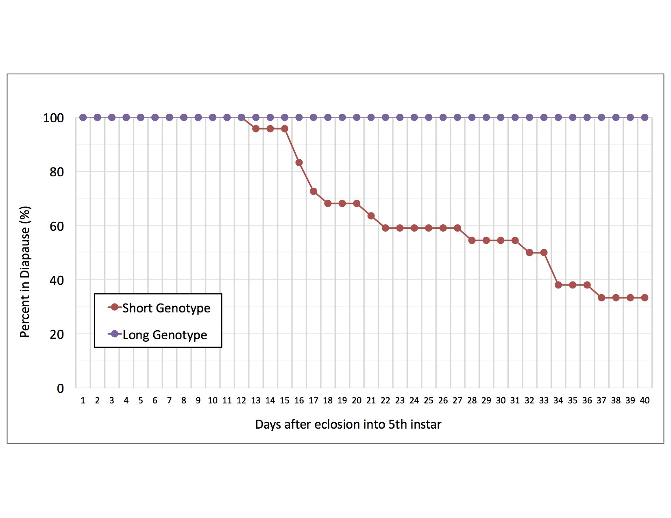

Figure 3-1. Percentage of diapause-programmed larvae in diapause across a 40-day trial starting on the first day of the final instar. Among long-diapause (purple) genotype individuals, 100% remained larvae throughout the 30-day trial and were classified as

"deep" diapause larvae. Among the short-diapause genotype individuals (red), 66.6% exited diapause before the end of the trial and classified as "shallow" diapause individuals while 33.3% of individuals remained as larvae throughout the 30-day trial and were classified as "deep" diapause larvae.

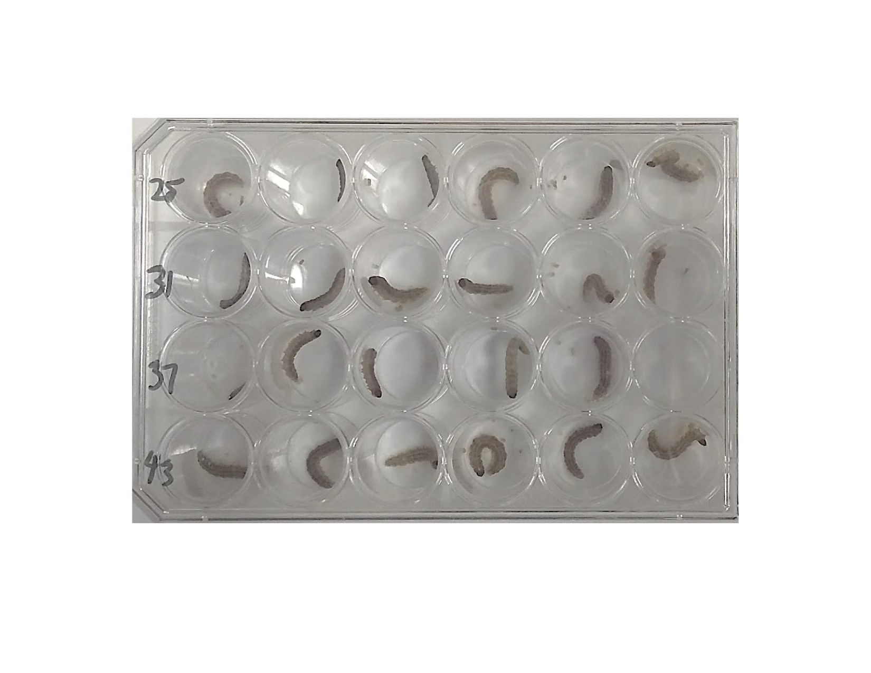

Figure 3-2. 24-well plate used to hold larvae during wandering assay. Wandering plate with larvae, April 1, 2018. Courtesy of the author, James Brown.

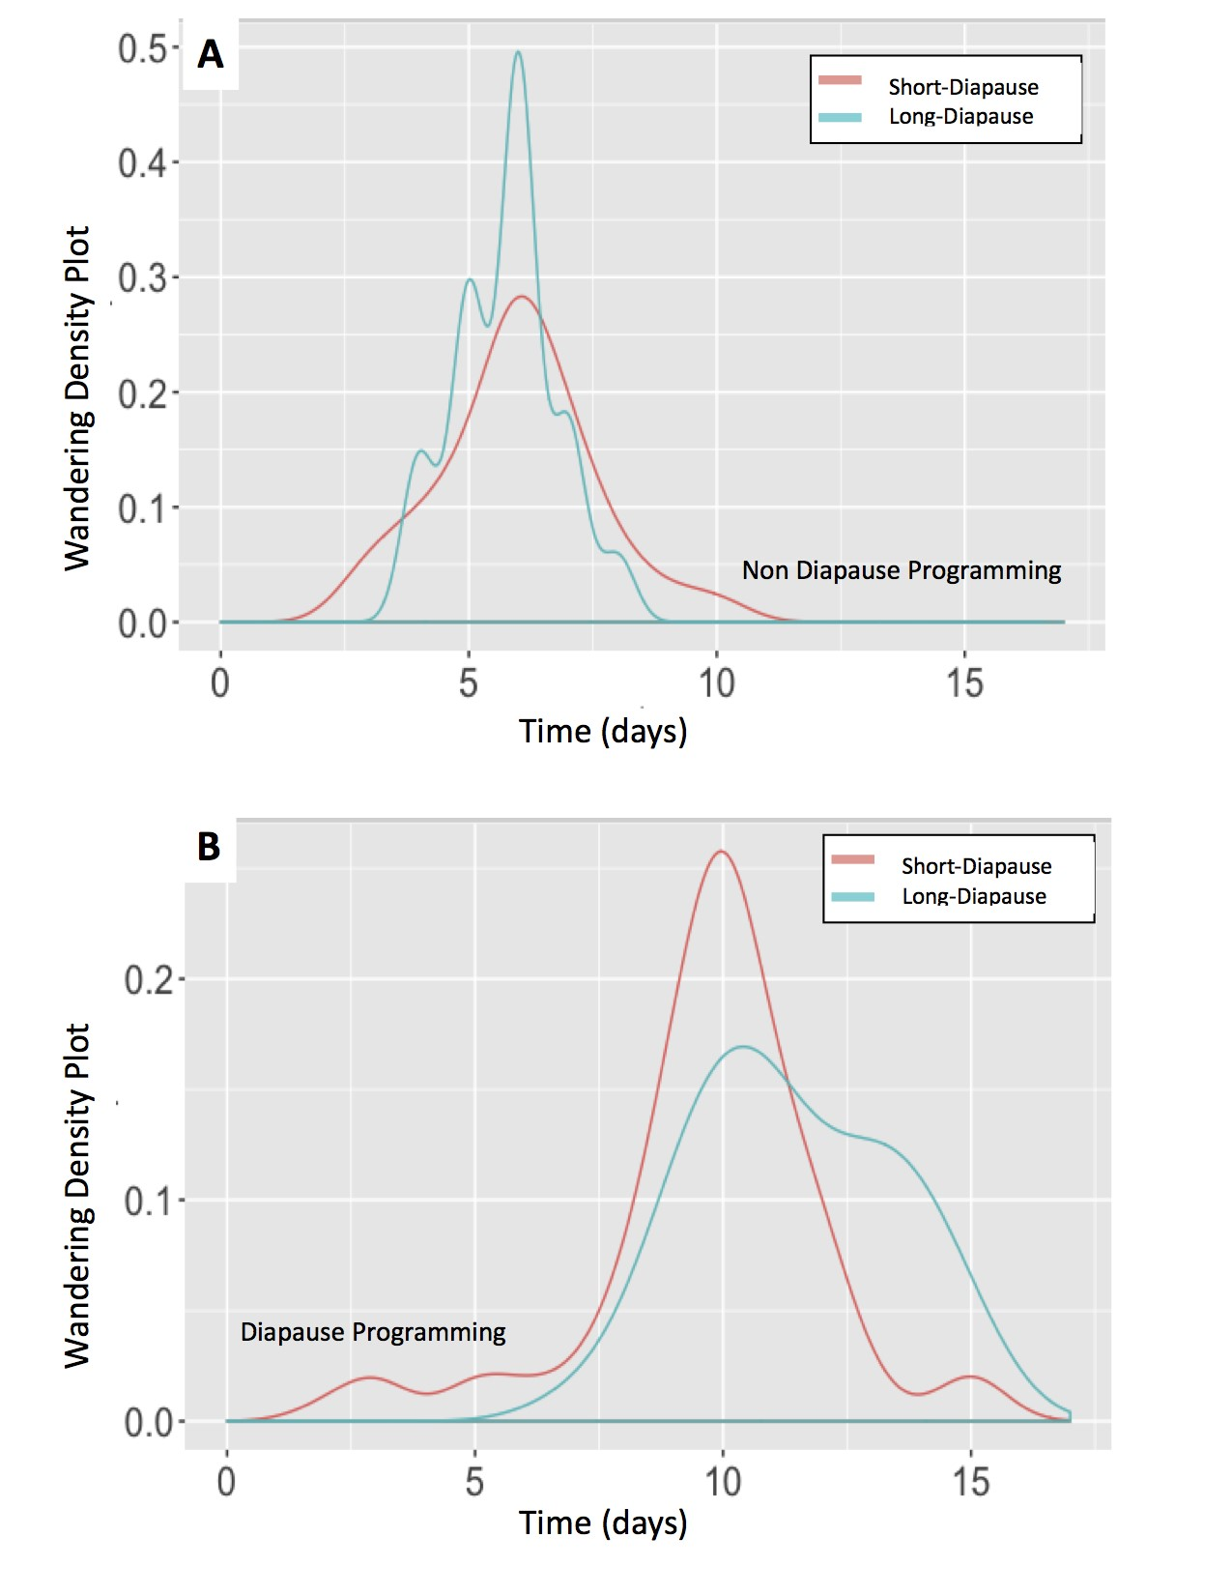

Figure 3-3. Distribution of larvae entering the wandering stage and the number of day after

eclosion into the final larval instar required to reach the wandering stage when reared in non-diapause conditions and diapause programming conditions. Most short-diapause and long-diapause genotype larvae in non-diapause (A) conditions reached the wandering stage 6 days after eclosing into the final larval instar. When reared in diapause programming conditions (B), most short-diapause and long-diapause genotype larvae reached the wandering stage 10 days after eclosing into the final larval instar.

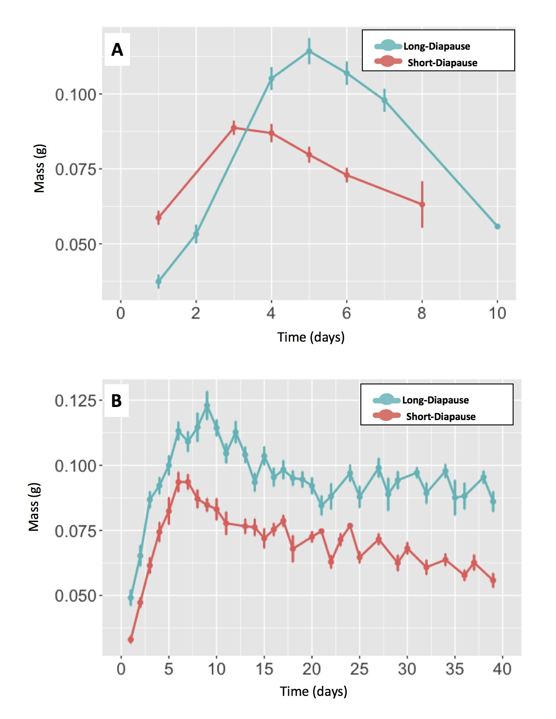

Figure 3-4. The rate of wet mass accumulation among larvae in diapause programming and non-diapause conditions. When reared in non-diapause conditions (A), wet mass peaked in short-diapause genotype larvae (red) 3 days after eclosing into the last larval instar and long-diapause genotype larvae (blue) reached their peak in wet mass 5 days after eclosing into the last larval instar. Among larvae reared in diapause programming condition (B), short-diapause genotype larvae (red) reached their peak in wet mass 6 days after entering the last larval instar while long-diapause genotype larvae (blue) reached their peak in wet mass 9 days after eclosion into the last larval instar.

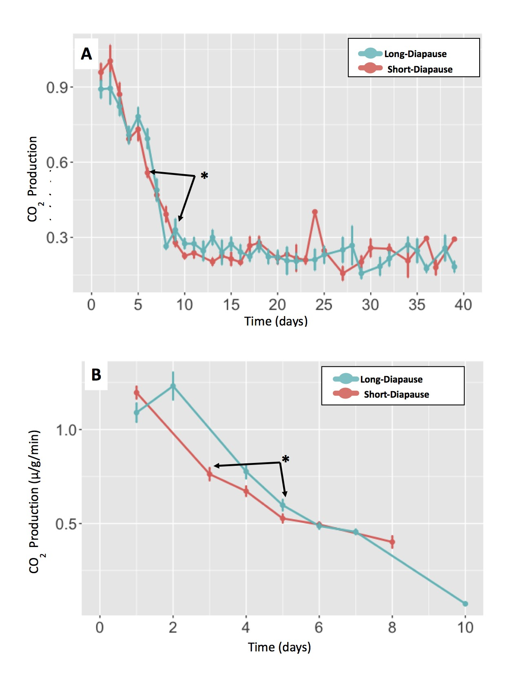

Figure 3-5. Comparing CO2 production of larvae with different diapause genotypes reared in the same photoperiod conditions. Co2 production was compared on the day wet mass peaked. Black arrows point towards wet mass peak days and asterisks "*" represent significance. (A) Comparing CO2 production between the long-diapause genotype (blue) and the short-diapause genotype (red) in diapause programming conditions. Mass peak days: day-9 for the long-diapause genotype and day-6 for the short-diapause genotype. CO2 production at day-9 was significantly different than day-6 (F-statistic=30.31, Df=26, p-value*<*0.000). (B) CO2 production comparison between the long-diapause genotype (blue) and the short-diapause genotype (red) in non-diapause conditions. Mass peak days: day-5 for the long-diapause genotype and day-3 for the short-diapause genotype. CO2 production was significantly difference on day-5 (F-statistic=13.99, Df=47, p-value*<*0.000)

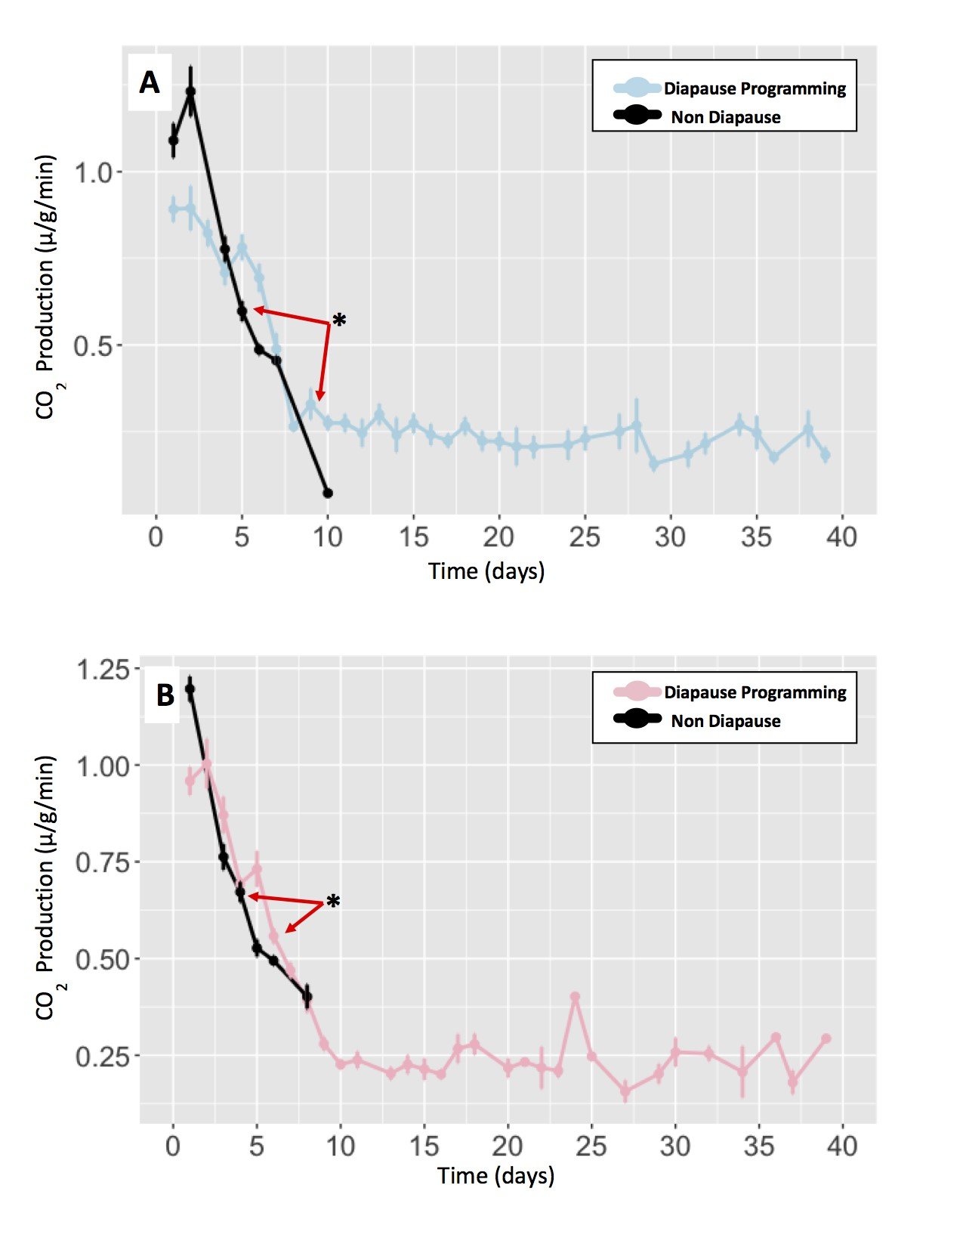

Figure 3-6. Comparing CO2 production among larvae with the same diapause genotype reared in diapause programming and non-diapause conditions. Co2 production was compared on the day wet mass peaked. Red arrows point towards wet mass peak days and asterisks "*" represent significance. (A) CO2 production compared between long-diapause genotype larvae in diapause programming conditions (blue) and non-diapause conditions (black). Mass peak days: day-9 reared in diapause programming conditions and day-5 in non-diapause conditions. CO2 production in diapause-programmed larvae was significantly different (F-statistic=22.52, DF=30, p-value*<*0.000). (B) CO2 production compared between short-diapause genotype larvae reared in diapause programming conditions (pink) and non-diapause conditions (black). Mass peak days: day-6 in diapause programming conditions and day-3 in non-diapause conditions. CO2 production in diapause-programmed larvae was significantly different (F-statistic=24.91, DF=43, p-value*<*0.000).

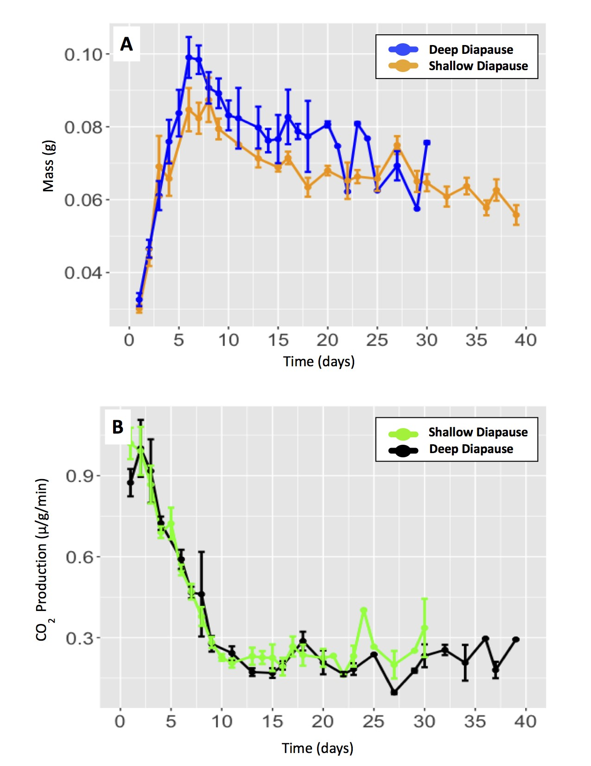

Figure 3-7. Comparing the day wet mass peaked and comparing CO2 production on mass peak day between deep and shallow-diapause larvae in diapause programming conditions. (A) Comparing mass peak days between short-diapause larvae demonstrating a shallow-diapause phenotype (orange) and a deep-diapause phenotype (blue). Mass peak days: day-6 for shallow-diapause larvae and day-6 for deep-diapause larvae. (B) Comparing CO2 production between short-diapause larvae in deep-diapause (black) shallow-diapause (green). No significance difference in CO2 production between shallow-diapause and deep-diapause larvae (F-statistic=1.068, DF=14, p-value=0.319).

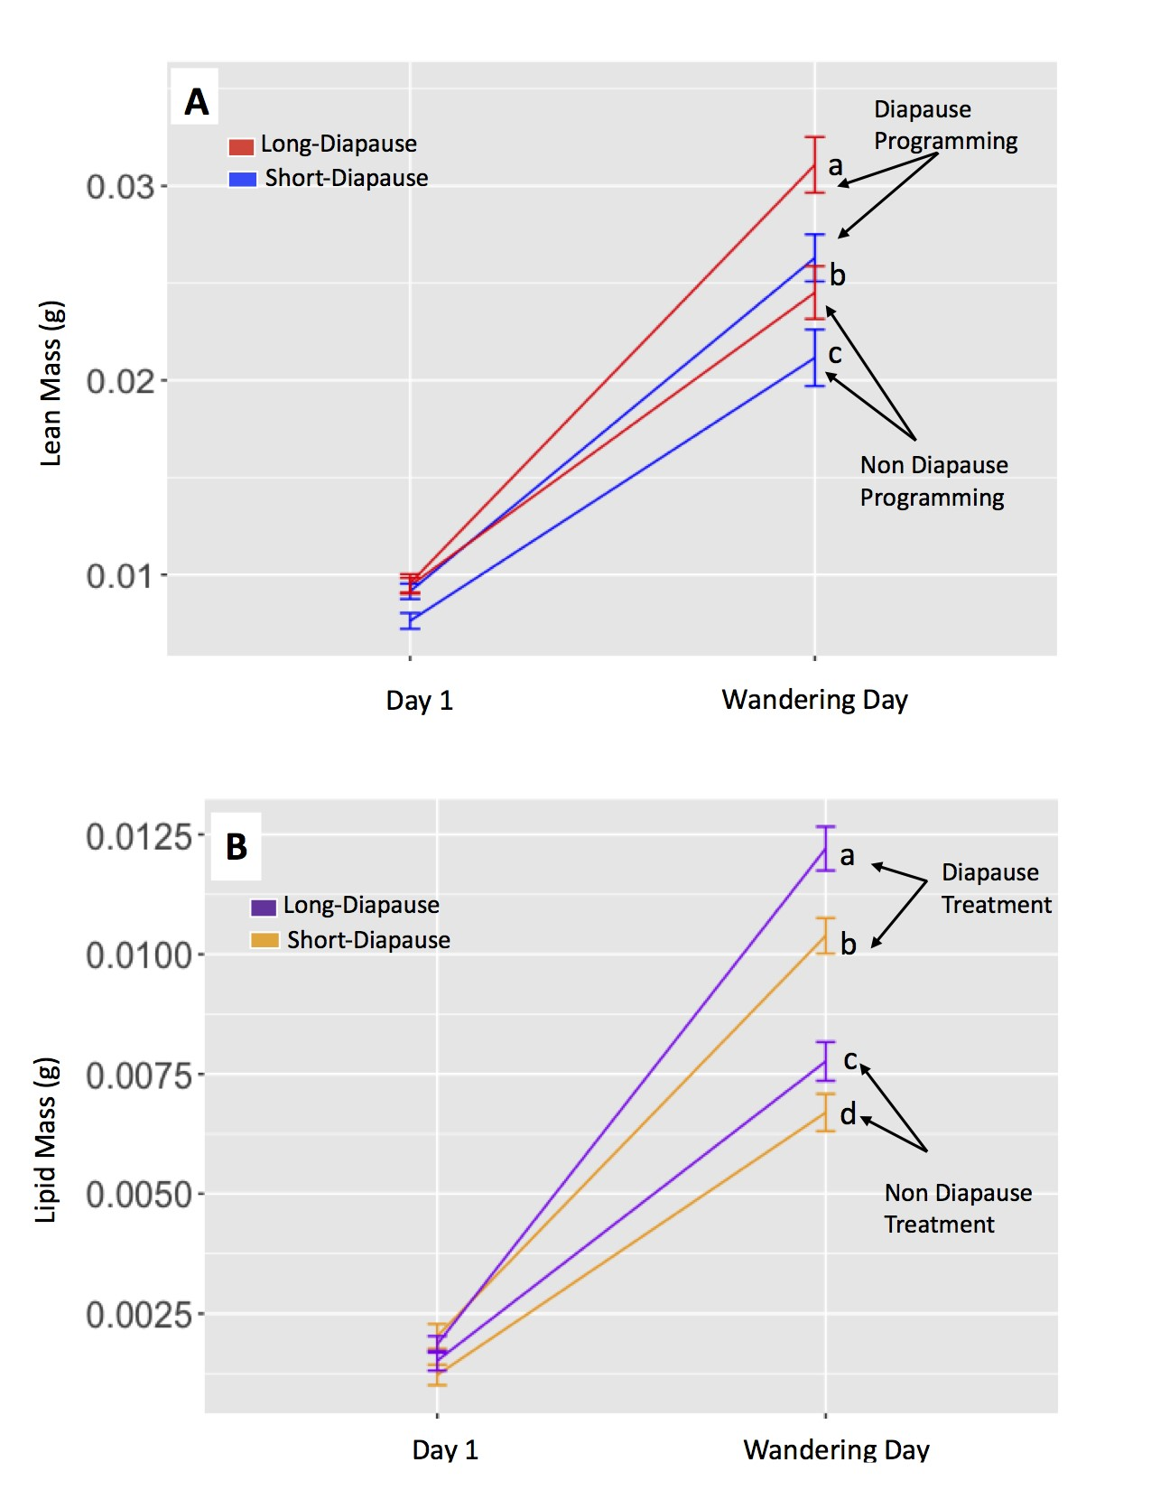

Figure 3-8. Comparing differences in lean mass and lipid mass accumulation prior to the onset of diapause between individuals reared in diapause programming and non-diapause conditions. Lower case letters represent significance. (A) Lean mass accumulation comparison between long-diapause genotype (red) and the short-diapause genotype (blue) individuals prior to the onset of diapause. Lean mass accumulation between individuals reared in diapause programming conditions (a and b) and non-diapause conditions (b and c) was significantly effected by diapause genotype (t-value=6.85,Df=10.9, p-value*<*0.000) and photoperiod (t-value=-9.66, Df=133.3, p-value*<*0.000). (B) Comparing lipid mass accumulation between long-diapause genotype larvae (purple) and short-diapause genotype larvae (orange) prior to the onset of diapause. Lipid mass accumulation between diapause programed individuals (a and b) and individuals in non-diapause conditions (c and d) was significantly effected by diapause genotype (t-value=4.08, Df=186.8, p-value*<*0.000) and photoperiod (t-value=-10.23, Df=191.6, p-value*<*0.000).

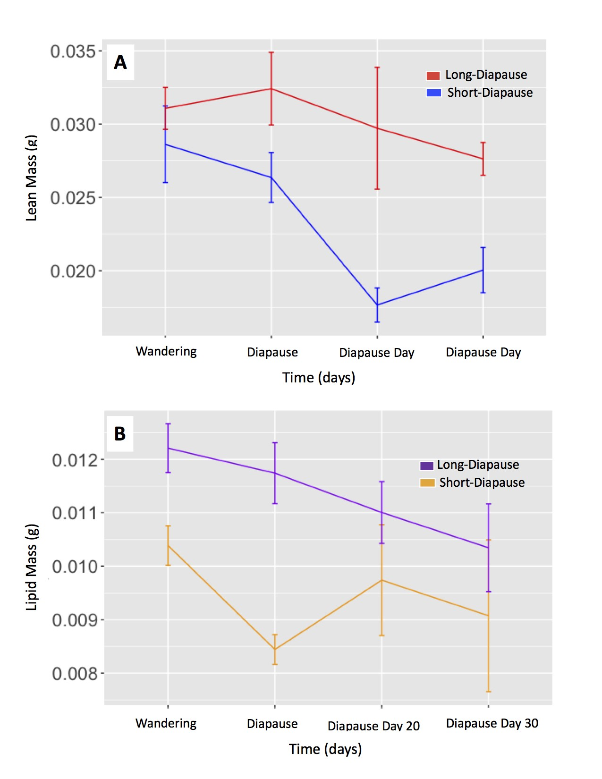

Figure 3-9. Comparing lipid mass depletion and lean mass depletion between individuals reared in diapause programming conditions and non-diapause conditions after the onset of diapause. (A) Comparing lean mass depletion during diapause between the long-diapause genotype (red) and short-diapause genotype (blue). Lean mass depletion during diapause was significantly different between diapause genotypes (t-value=2.45, Df=10.7,p-value=0.033). Lean mass did not significantly change among larvae within a single diapause genotype during diapause (3-7A,B). (B) Comparing lipid mass depletion between the long-diapause genotype (purple) and the short-diapause genotype (orange). Lipid mass depletion during diapause was significantly effected by diapause genotype (t-value=4.74, Df=16.7,

p-value=0.000) and Sample day fifteen significantly effected lipid mass depletion (t-value=-2.38, Df=14.1,p-value=0.032). Lipid mass depletion among long-diapause genotype larvae did not significantly change during diapause (3-9A). Among short-diapause genotype larvae, lipid mass depletion was only significantly different on day 15 (t-value=-3.88, Df=111.4,p-value*<*0.000) (3-9B).

Table 3-1. Linear models comparing CO2 production between diapause genotypes and photoperiods on the day wet mass peaked.

|  |  |  |  |
| --- | --- | --- | --- |
| Model | Df | t value | P |
| A). CO2 production between individuals in diapause conditions  Diapause Genotype | 26 | -5.51 | *<*0.000* |
| B). CO2 production between individuals in non-diapause conditions  Diapause Genotype | 47 | -3.74 | 0.001* |
| C). CO2 production among long-diapause individuals  Photoperiod | 30 | 4.47 | *<*0.000* |
| D). CO2 production among short-diapause individuals  Photoperiod | 43 | 5.0 | *<*0.000* |
| E). CO2 production between shallow and deep-diapause individuals  Diapause phenotype | 14 | -1.03 | 0.319*ns* |

Table 3-2. FULL MODEL: ANOVA summary table for the additive and interactive effects of photoperiod and diapause genotype, and the effect of lean mass on lipid mass accumulation. Asterisks "*" indicate statistical significance, ns represents non significant results.

|  |  |  |  |
| --- | --- | --- | --- |
| Model | Df | F | P |
| A). Lipid mass accumulation on first day of final larval instar |  |  |  |
| Diapause Genotype | 77.4 | 0.16 | 0.696*ns* |
| Photoperiod | 75.9 | 7.43 | 0.008* |
| Lean Mass | 79.6 | 8.61 | 0.004* |
| Diapause Genotype x Photoperiod | 74.4 | 0.17 | 0.684*ns* |
| B). Lipid mass accumulation on wandering day |  |  |  |
| Diapause Genotype | 186.8 | 16.65 | *<*0.000* |
| Photoperiod | 191.6 | 104.74 | *<*0.000* |
| Lean Mass | 16.3 | 0.01 | 0.927*ns* |
| Diapause Genotype x Photoperiod | 186.2 | 1.46 | 0.228*ns* |

Table 3-3. FULL MODEL: ANOVA summary table for the additive and interactive effects of sample day and diapause genotype, and the effect of lean mass on lipid mass depletion. Asterisks "*" indicate statistical significance, ns represents non significant results.

|  |  |  |  |
| --- | --- | --- | --- |
| Model | Df | F | P |
| Lipid mass during the first 30-days of diapause |  |  |  |
| Diapause Genotype | 25.3 | 17.50 | 0.000* |
| Sample Day | 20.4 | 63.87 | *<*0.000* |
| Lean Mass | 37.9 | 1.37 | 0.248*ns* |
| Diapause Genotype x Sample Day | 16.1 | 2.05 | 0.135*ns* |

Table 3-4. FULL MODEL: ANOVA summary table for the additive and interactive effects of photoperiod and diapause genotype and the effect of lean mass accumulation.

Asterisks "*" indicate statistical significance, ns represents non significant results.

|  |  |  |  |
| --- | --- | --- | --- |
| Model | Df | F | P |
| A). Lean mass accumulation on first day of final larval instar |  |  |  |
| Diapause Genotype | 1 | 1.44 | 0.233*ns* |
| Photoperiod | 1 | 1.07 | 0.304*ns* |
| Diapause Genotype x Photoperiod | 1 | 1.52 | 0.221*ns* |
| B). Lean mass accumulation on wandering day |  |  |  |
| Diapause Genotype | 10.9 | 46.86 | 0* |
| Photoperiod | 133.3 | 93.81 | *<*0.000* |
| Diapause Genotype x Photoperiod | 129.7 | 0.12 | 0.734*ns* |

Table 3-5. FULL MODEL: ANOVA summary table for the additive and interactive effects of

sample day and diapause genotype on lean mass depletion. Asterisks "*" indicate statistical significance, ns represents non significant results.

|  |  |  |  |
| --- | --- | --- | --- |
| Model | Df | F | P |
| Lean mass depletion during the first 30-days of diapause |  |  |  |
| Diapause Genotype | 18.7 | 6.00 | 0.025* |
| Sample Day | 21.2 | 8.77 | *<*0.000* |
| Diapause Genotype x Sample Day | 9.8 | 1.19 | 0.374*ns* |

Table 3-3. REDUCED MODEL: Linear mixed effects model table for lean mass accumulation between long-diapause genotype and short-diapause genotype larvae in diapause programming and non-diapause conditions. Asterisks "*" indicate statistical significance, ns represents non significant.

|  |  |  |  |
| --- | --- | --- | --- |
| Model | Df | t value | P |
| A). Lean mass on first day of final larval instar |  |  |  |
| Diapause Genotype | 5.9 | 2.03 | 0.089*ns* |
| Photoperiod | 77.7 | -1.13 | 0.261*ns* |
| B). Lean mass on wandering Day |  |  |  |
| Diapause Genotype | 10.9 | 6.85 | *<*0.000* |
| Photoperiod | 133.3 | -9.66 | *<*0.000* |

Table 3-5. REDUCED MODEL: Linear mixed effects model table for lipid mass accumulation between long-diapause genotype and short-diapause genotype larvae in diapause programming and non-diapause conditions. Asterisks "*" indicate statistical significance, ns represents non significant.

|  |  |  |  |
| --- | --- | --- | --- |
| Model | Df | t value | P |
| A). Lipid mass on first day of final larval instar |  |  |  |
| Lean Mass | 79.6 | 2.93 | 0.004* |
| Photoperiod | 75.9 | -2.73 | 0.008* |
| B). Lipid mass on wandering day |  |  |  |
| Diapause Genotype | 186.8 | 4.08 | *<*0.000* |
| Photoperiod | 191.6 | -10.23 | *<*0.000* |

Table 3-7. REDUCED MODEL: Linear mixed effects model for lean mass depletion between long-diapause and short-diapause genotypes, among long-diapause genotype larvae, and among short-diapause genotype larvae during diapause. Asterisks "*" indicate statistical significance, ns represents non significant.

|  |  |  |  |
| --- | --- | --- | --- |
| Model | Df | t value | P |
| A). Lean mass depletion: Between genotypes |  |  |  |
| Diapause genotype | 10.7 | 2.45 | 0.033* |
| Diapause Day 15 | 16.5 | 0.18 | 0.861*ns* |
| Diapause Day 20 | 15.2 | -0.56 | 0.586*ns* |
| Diapause Day 30 | 16.0 | -0.68 | 0.504*ns* |
|  |  |  |  |
| A). Lean mass depletion: Long-diapause genotype |  |  |  |
| Diapause Day 15 | 11.7 | 0.18 | 0.859*ns* |
| Diapause Day 20 | 9.8 | -0.27 | 0.792*ns* |
| Diapause Day 30 | 10.4 | -0.35 | 0.736*ns* |
| C). Lean mass depletion: Short-diapause genotype |  |  |  |
| Diapause Day 15 | 14.1 | -0.27 | 0.793*ns* |
| Diapause Day 20 | 13.6 | -1.10 | 0.292*ns* |
| Diapause Day 30 | 25.0 | -1.00 | 0.328*ns* |

Table 3-9. REDUCED MODEL: Linear mixed effects model for lipid mass depletion between long-diapause genotype and short-diapause genotype larvae, among long-diapause genotype larvae, and short-diapause genotype larvae during diapause. Asterisks "*" indicate statistical significance, ns represents non significant.

|  |  |  |  |
| --- | --- | --- | --- |
| Model | Df | t value | P |
| A). Lipid mass depletion: Between genotypes |  |  |  |
| Diapause genotype | 16.7 | 4.74 | *<*0.000* |
| Diapause Day 15 | 14.1 | -2.38 | 0.031* |
| Diapause Day 20 | 15.8 | -1.09 | 0.294*ns* |
| Diapause Day 30 | 15.2 | -1.53 | 0.148*ns* |
| B). Lipid mass depletion: Long-diapause genotype |  |  |  |
| Diapause Day 15 | 11.9 | -0.38 | 0.714*ns* |
| Diapause Day 20 | 9.4 | -0.90 | 0.389*ns* |
| Diapause Day 30 | 9.9 | -0.74 | 0.476*ns* |
| C). Lean mass depletion: Short-diapause genotype |  |  |  |
| Diapause Day 15 | 111.4 | -3.88 | *<*0.000* |
| Diapause Day 20 | 111.4 | 0.75 | 0.454 |
| Diapause Day 30 | 111.4 | -1.01 | 0.314 |

REFERENCES

Adkisson, P. L., R. A. Bell, and S. G. Wellso. 1963. Environmental factors controlling the induction of diapause in the pink bollworm, Pectinophora gossypiella (Saunders). Journal of

Insect Bohnenblustct Physiology 9:299–310.

Allison, J. D. and R. T. Cardé. 2016. Pheromone Communication in Moths: Evolution,

Behavior, and Application. illustrate edition. University of California Press.

Arrese, E. L. and J. L. Soulages. 2010. Insect Fat Body: Energy, Metabolism, and Regulation.

Annual Review of Entomology 55:207–225.

Beck, S. D. and J. W. Apple. 1961. Effects of temperature and photoperiod on voltinism of geographical populations of the European corn borer, Pyrausta nubilalis. Journal of economic entomology 54:550–558.

Bohnenblust, E. and J. Tooker. 2010. European corn borer in field corn. Entomologial Notes .

Bradshaw, W. E. and C. M. Holzapfel. 2001. Genetic shift in photoperiodic response correlated with global warming. Proceedings of the National Academy of Sciences of the United States of America 98:14509–14511.

Breed, G. A., S. Stichter, and E. E. Crone. 2012. Climate-driven changes in northeastern US butterfly communities. Nature Climate Change 3:142–145.

Capinera, J. L. E. and N. Department). 2000. European corn borer scientific name : Ostrinia nubilalis ( Hübner ) ( Insecta : Lepidoptera : Pyralidae ) (EENY-156). Gainesville: University of Florida Institute of Food and Agricultural Sciences .

Chown, S. L. 2007. Physiological diversity in insects: Ecology and evolutionary contexts.

Advances in Insect Physiology 33:50–152.

de Gruyter, W. 1999. Handbook of Zoology. 35. Lepidoptera, Moths and Butterflies Volume 1:

Evolution, Systematics, and Biogeography. Pages 80–82 *in* N. P. Kristensen, editor. Tropical Lepidoptera. 10, Verlag.

DeLucia, E. H., C. L. Casteel, P. D. Nabity, and B. F. O’Neill. 2008. Insects take a bigger bite out of plants in a warmer, higher carbon dioxide world. Proceedings of the National Academy

of Sciences 105:1781–1782.

Dopman, E. B., L. Perez, S. M. Bogdanowicz, and R. G. Harrison. 2005. Consequences of reproductive barriers for genealogical discordance in the European corn borer. Proceedings of the National Academy of Sciences 102:14706–14711.

Dugdale, J. 1995. Index of economically important Lepidoptera. Cambridge University Press.

Frolov, A. N., D. Bourguet, and S. Ponsard. 2007. Reconsidering the taxomony of several

Ostrinia species in the light of reproductive isolation: A tale for Ernst Mayr.

Gelman, D. B., and D. K. Hayes. 1982. Methods and Markers for Synchronizing Maturation of

Fifth-Stage Larvae and Pupae of the European Corn Borer , Ostrinia nubilalis. Annals of the

Entomological Society of Americ 75:485–493.

Gomi, T., M. Nagasaka, T. Fukuda, and H. Hagihara. 2007. Shifting of the life cycle and life-history traits of the fall webworm in relation to climate change. Entomologia

Experimentalis et Applicata 125:179–184.

Gossert, A. D., A. Hinniger, S. Gutmann, W. Jahnke, A. Strauss, and C. Fernández. 2011. A simple protocol for amino acid type selective isotope labeling in insect cells with improved yields and high reproducibility.

Hahn, D. A. and D. L. Denlinger. 2007. Meeting the energetic demands of insect diapause:

Nutrient storage and utilization. Journal of Insect Physiology 53:760–773.

Huey, R. B. and R. D. Stevenson. 1979. Integrating thermal physiology and ecology of ectotherms: A discussion of approaches. Integrative and Comparative Biology 19:357–366.

Hyde, J., M. A. Martin, P. V. Preckel, and C. R. Edwards. 1999. The economics of Bt corn: Valuing protection from the European corn borer. Review of Agricultural Economics 21:442–454.

Ikten, C., S. R. Skoda, T. E. Hunt, J. Molina-Ochoa, and J. E. Foster. 2011. Genetic Variation and Inheritance of Diapause Induction in Two Distinct Voltine Ecotypes of Ostrinia nubilalis (Lepidoptera: Crambidae). Annals of the Entomological Society of America 104:567–575.

IPCC. 2013. Summary for Policymakers. In: Climate Change 2013: The Physical Science Basis.

Contribution of Working Group I to the Fifth Assessment Report of the Intergovernmental

Panel on Climate Change. Technical report, Intergovernmental Panel on Climate Change, Cambridge.

Kim, C.G., S. Hoshizaki, Y.-p. Huang, S. Tatsuki, and Y. Ishikawa. 1999. Usefulness of mitochondrial COII gene sequences in examining phylogenetic relationships in the Asian corn borer, Ostrinia furnacalis, and allied species (Lepidoptera : Pyralidae). Applied Entomology and Zoology 34:405–412.

Koštál, V. 2006. Eco-physiological phases of insect diapause. Journal of Insect Physiology

52:113–127.

Lassance, J.-M., A. T. Groot, M. A. Liénard, B. Antony, C. Borgwardt, F. Andersson, E. Hedenström, D. G. Heckel, and C. Löfstedt. 2010. Allelic variation in a fatty-acyl reductase gene causes divergence in moth sex pheromones. Nature 466:486–489.

Levy, R. C., G. M. Kozak, C. B. Wadsworth, B. S. Coates, and E. B. Dopman. 2015.

Explaining the sawtooth: Latitudinal periodicity in a circadian gene correlates with shifts in generation number. Journal of Evolutionary Biology 28:40–53.

McLeod, D., and S. D. Beck. 1963. Photoperiodic Termination of Diapause. The Biological

Bulletin 124:84–96.

Mitchell, C. J., and H. Briegel. 1989. Inability of diapausing Culex pipiens (Diptera: Culicidae) to use blood for producing lipid reserves for overwinter survival. Journal of medical entomology 26:318–26.

Mutuura, A., and E. Munroe. 1970. Taxonomy and distribution of the European corn borer and allied species: genus Ostrinia (Lepidoptera: Pyralidae). Mem. Entomol. soc. Can.

102:1–112.

Nechols, J., M. J. Tauber, C. A. Tauber, and S. Masaki, 1999. Nechols et al 1999 Adaptations to Hazardous Seasonal.pdf. Chapter adaptation, pages 159–200 *in* Huffaker and Gutierrex, editors. Ecological Entomology. 2 edition.

NOAA National Centers for Environmental Information, 2017. State of the Climate: Global Climate Report for Annual 2016.

Parmesan, C., N. Ryrholm, C. Stefanescu, J. K. Hill, C. D. Thomas, H. Descimon, B. Huntley, L. Kaila, J. Kullberg, T. Tammaru, W. J. Tennent, J. a. Thomas, and M. Warren. 1999.

Poleward shifts in geographical ranges of butterfly species associated with regional warming.

Nature 399:579–583.

R Development Core Team. 2016. R: A Language and Environment for Statistical Computing.

R Foundation for Statistical Computing Vienna Austria 0:3–900051.

Regier, J. C., C. Mitter, M. A. Solis, J. E. Hayden, B. Landry, M. Nuss, T. J. Simonsen, S. H.

Yen, A. Zwick, and M. P. Cummings. 2012. A molecular phylogeny for the pyraloid moths

(Lepidoptera: Pyraloidea) and its implications for higher-level classification. Systematic Entomology 37:635–656.

Roelofs, W. L., J. W. Du, X. H. Tang, P. S. Robbins, and C. J. Eckenrode. 1985. Three

European corn borer populations in New York based on sex pheromones and voltinism.

Journal of Chemical Ecology 11:829–836.

Sakurai, S., M. Kaya, and S. Satake. 1998. Hemolymph ecdysteroid titer and ecdysteroid-dependent developmental events in the last-larval stadium of the silkworm, Bombyx mori: Role of low ecdysteroid titer in larval-pupal metamorphosis and a reappraisal of the head critical period. Journal of Insect Physiology 44:867–881.

Saunders, D. S. 1997. UnderâĂŘsized larvae from shortâĂŘday adults of the blow fly,

Calliphora vicina, sideâĂŘstep the diapause programme. Physiological Entomology

22:249–255.

Showers, W. B., H. C. Chiang, A. J. Keaster, R. E. Hill, G. L. Reed, A. N. Sparks, and G. J.

Musick. 1975. Ecotypes of the European corn borer in North America. Environmental Entomology 4:753–760.

Sinclair, B. J. 2015. Linking energetics and overwintering in temperate insects. Journal of

Thermal Biology 54:5–11.

Solis, M. A. 2007. Phylogenetic studies and modern classification of the Pyraloidea

(Lepidoptera). Revista Colombiana de Entomología 33:1–9.

Tauber, C. A., and M. J. Tauber. 1981. Insect seasonal cycles: genetics and evolution. Annual Review of Ecology and Systematics 12:281–308.

Thompson, A. C., and F. M. Davis. 1981. The effect of temperature on the rate of metabolism of lipids and glycogen in diapausing southwestern corn borer, Diatraea grandiosella.

Comparative Biochemistry and Physiology – Part A: Physiology 70:555–558.

Vukašinović, E. L., D. W. Pond, M. R. Worland, D. Kojić, J. Purać, D. P. Blagojević, and G. Grubor-Lajšić. 2013. Diapause induces changes in the composition and biophysical properties of lipids in larvae of the European corn borer, Ostrinia nubilalis (Lepidoptera: Crambidae). Comparative Biochemistry and Physiology Part B: Biochemistry and Molecular Biology 165:219–225.

Wadsworth, C. B., X. Li, and E. B. Dopman. 2015. A recombination suppressor contributes to ecological speciation in OSTRINIA moths. Heredity 114:593–600.

Wahlberg, N., C. W. Wheat, and C. Peña. 2013. Timing and patterns in the taxonomic diversification of Lepidoptera (butterflies and moths). PLoS ONE 8:80875.

Williams, C. M., H. A. Henry, and B. J. Sinclair. 2015. Cold truths: How winter drives responses of terrestrial organisms to climate change. Biological Reviews 90:214–235.

Williams, C. M., K. E. Marshall, H. A. MacMillan, J. D. Dzurisin, J. J. Hellmann, and B. J. Sinclair. 2012. Thermal variability increases the impact of autumnal warming and drives metabolic depression in an overwintering butterfly. PLoS ONE 7:e34470.

Wipking, W., M. Viebahn, and D. Neumann. 1995. Oxygen consumption, water, lipid and glycogen content of early and late diapause and non-diapause larvae of the burnet moth

Zygaena trifolii. Journal of Insect Physiology 41:47–56.

BIOGRAPHICAL SKETCH

James Brown, a Florida native, was born in 1984 in Ft. Lauderdale, Florida and grew up in West Palm Beach, Florida. James grew up curious about the biology of the natural world and leading him to pursue a secondary school education in biological science. At the University of Maryland, College Park, James majored in biological sciences with a concentration in Cell Biology and Molecular Genetics. James received his Bachelor of Biological Science in 2010 and began working in the Insect Behavior and Biological Control Unit of the USDA-ARS CMAVE in Gainesville, Florida before starting his master’s degree. James received his master’s degree in entomology at the University of Florida in May 2019, and is expected to pursue a PhD in

Entomology.